**Technical Documentation**

By Sanket Prabhu (srp140430)

*Technical Documentation for UTD Degree Planner* ii

Contents

1. Project Overview 3

2. Assumptions 4

3. Project Flow 4

4. Test Plan and test cases 4

4.1 Test Plan 4

4.2 Test coverage: 5

4.3 Test methods: 5

4.4 Test responsibilities: 5

4.5 Test Scenario 5

4.6 Test cases screenshots 6

4.6.1 Test Case-I (Login) 6

4.6.2 Test Case-II (Logout) 7

4.6.3 Test Case-III (Registration) 8

4.6.4 Test Case-IV (Advisor availability) 10

4.6.5 Test Case-V (Add/delete Appointment by user) 11

4.6.6 Test Case-VI (Cancel scheduled appointment by advisor) 12

4.6.7 Test Case-VII (Change of track) 13

5 User Interface 14

5.1 Course Registration 14

5.2 Schedule an appointment with advisor 17

5.3 Change of Track 19

6 Source code 20

6.1 Index1.php 20

6.2 User.php 20

6.3 Admin.php 20

6.4 Advisor.php 20

6.5 Loginform.inc.php 20

# Project Overview

The main purpose of this project is to build Degree planner for Graduate students who are pursuing master’s degree using HTML, CSS, PHP, JavaScript and MySQL.

There are two major components in this system.

* Front end
* Backend

Front end consist of two parts:

* User
* Admin

Backend is designed using MySQL.

User can register and drop courses, whereas Admin can create/update/delete user, create/update/delete courses and create/update/delete tracks. Advisor can give their availability for daily appointments as well as cancel availability. Also students can book appointments for advisor1/advisor2 as well as cancel it. Advisor can see daily schedule of an appointment and can cancel scheduled appointment.

The application till now has following functionality:

* Admin can login using his credentials and his portal will be shown.
* Admin can add/update/delete users, add/update/delete courses and add/update/delete track plan.
* User can login into his system and he should be able to see his information.
* User can see his Core as well as Elective courses in his cart.
* User can add or drop courses according to his degree plan.
* User must fill acknowledgment policy form before registering courses.
* User can schedule an appointment with advisor or cancel an appointment.
* Advisor can create/delete daily appointments and can view/delete scheduled appointment.

# Assumptions

There exist many technologies and the resources which are shared my Dr. Min would be sufficient to complete this project without having many difficulties. There are assumptions which will be considered while building this project.

* User can Add prerequisites anytime during his course duration
* Courses can be added only once. So if he wants to repeat course then that will be an additional implementation.
* User can graduate register course even if he is on academic probation as implementing that will be additional module.
* User can graduate without completing prerequisites.
* After advising session, advisor can delete appointments so that it will be deleted from database.
* Registration for advising session will be for one day.

# Project Flow

First page of the project would be login page having 3 login options. That is for students, advisor and administrator. Project flow is well described in User Interface section of this document.

# Test Plan and test cases

## Test Plan

I have designed system similar to UTD eLearning where Admin can add students, add courses and tracks students can login into their portals and can register for courses. Advisor can give its availability and student can schedule/cancel an appointment. Admin can add/update delete courses, users as well as track. I am giving test plans using three points as shown below:

## 

## Test coverage:

Our system is really large. But in this exercise, we are planning to test 6 parts such as user login, logout, user registration, add User, daily availability, schedule and cancel appointment by user and cancel scheduled appointment by Advisor.

## Test methods:

We are using Selenium testing tool to create test cases for different scenarios such as Login, Logout and Add user function. We are using Firefox with selenium IDE extension to derive test cases.

## Test responsibilities:

We are performing these test cases to test three major functionalities of our system. Login phase and logout phase are important phases. To get those functions right we are deriving test cases to test systems so that deliverables would have minimum faults.

## Test Scenario

|  |  |
| --- | --- |
| Test Scenario | Expected Result |
| User with valid username and password should be allowed to login. | User should be displayed home page of their own portal. |

|  |  |
| --- | --- |
| Test Scenario | Expected Result |
| User with invalid username and password should not be allowed to login | User should be displayed an error with Invalid Username/Password |

|  |  |
| --- | --- |
| Test Scenario | Expected Result |
| User should not be logged off until he clicks logout or terminates his session by closing browser. | If user accidently closes browser, and he visits same url, then system should redirect him to login page. |

|  |  |
| --- | --- |
| Test Scenario | Expected Result |
| User should be allowed to log out of their system. | If user clicks on Logout button, then system should log out, kill that particular session and redirect it to Login page. |

|  |  |
| --- | --- |
| Test Scenario | Expected Result |
| Admin can add and edit user | Admin can login using his credentials and he can add and edit users by putting user information and clicking on Add User. |

|  |  |
| --- | --- |
| Test Scenario | Expected Result |
| Advisor can give availability, and view/cancel daily appointment | Advisor can login using credential and give availability as well as view and cancel daily appointment. |

|  |  |
| --- | --- |
| Test Scenario | Expected Result |
| User can change his track | User can login and select change track hyperlink. System will show preview and he needs to press yes to make changes and track of users will get changed. |

## Test cases screenshots

### Test Case-I (Login)

Login:

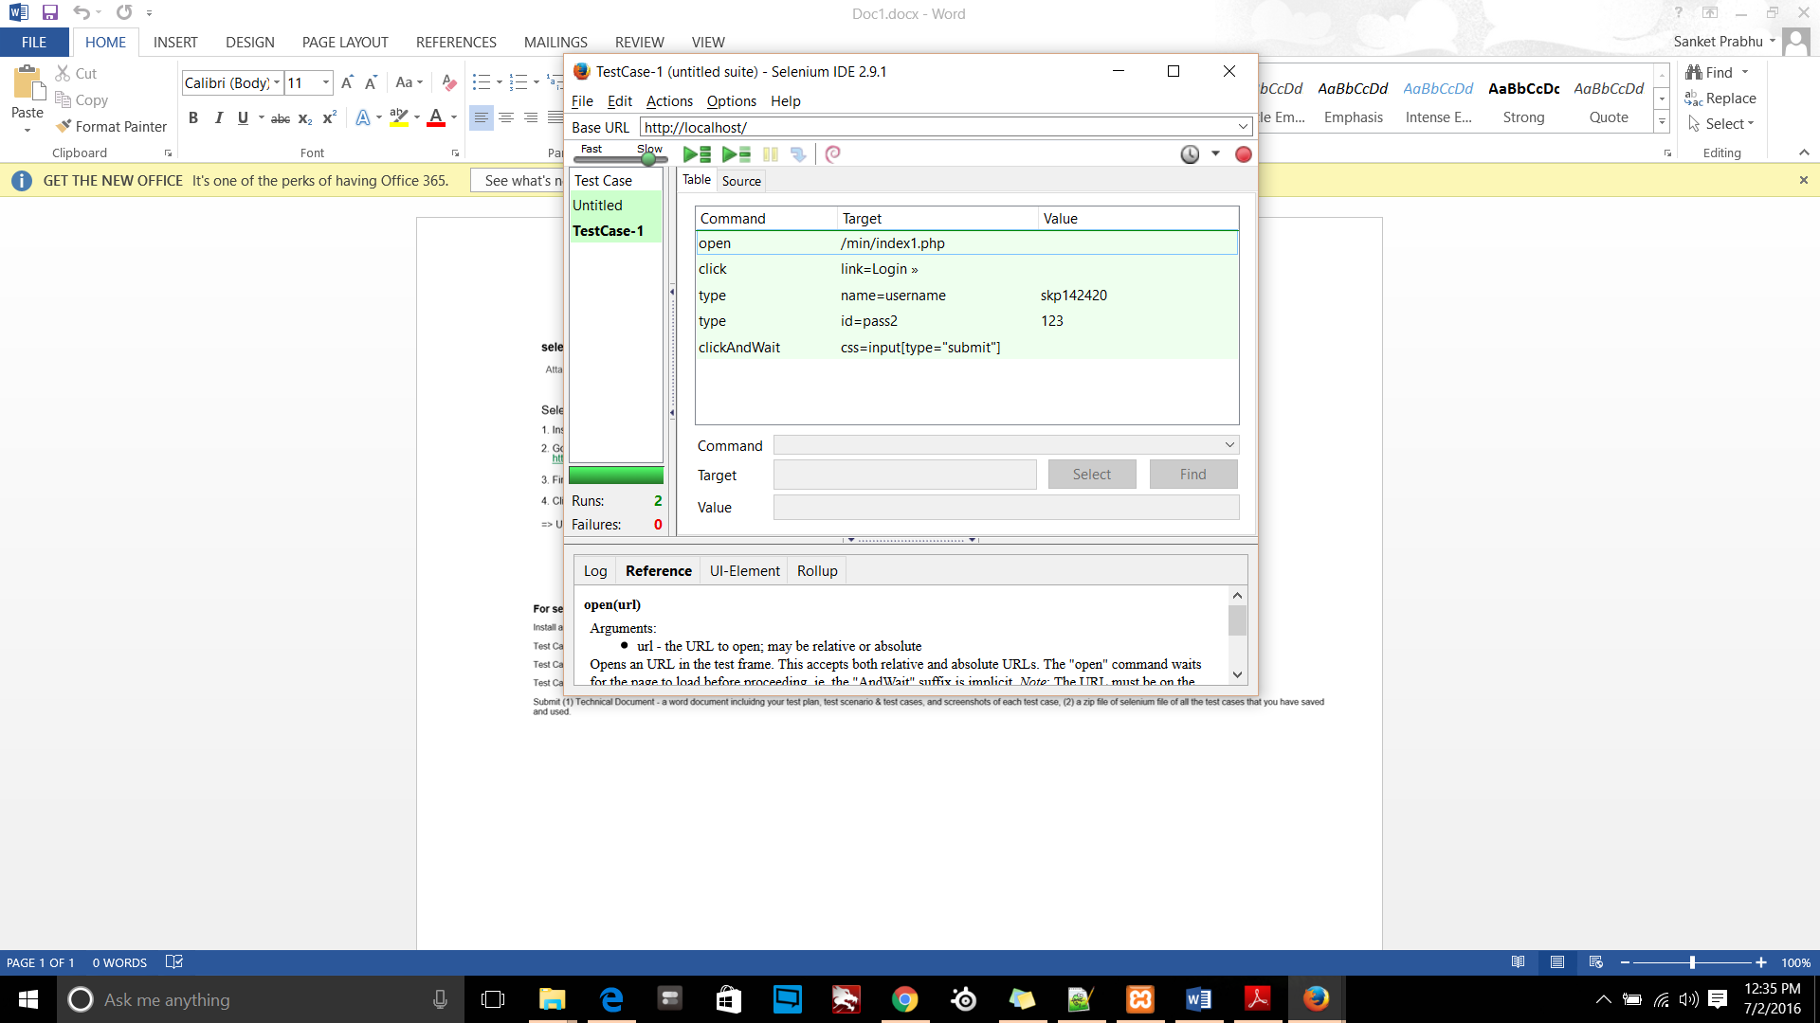

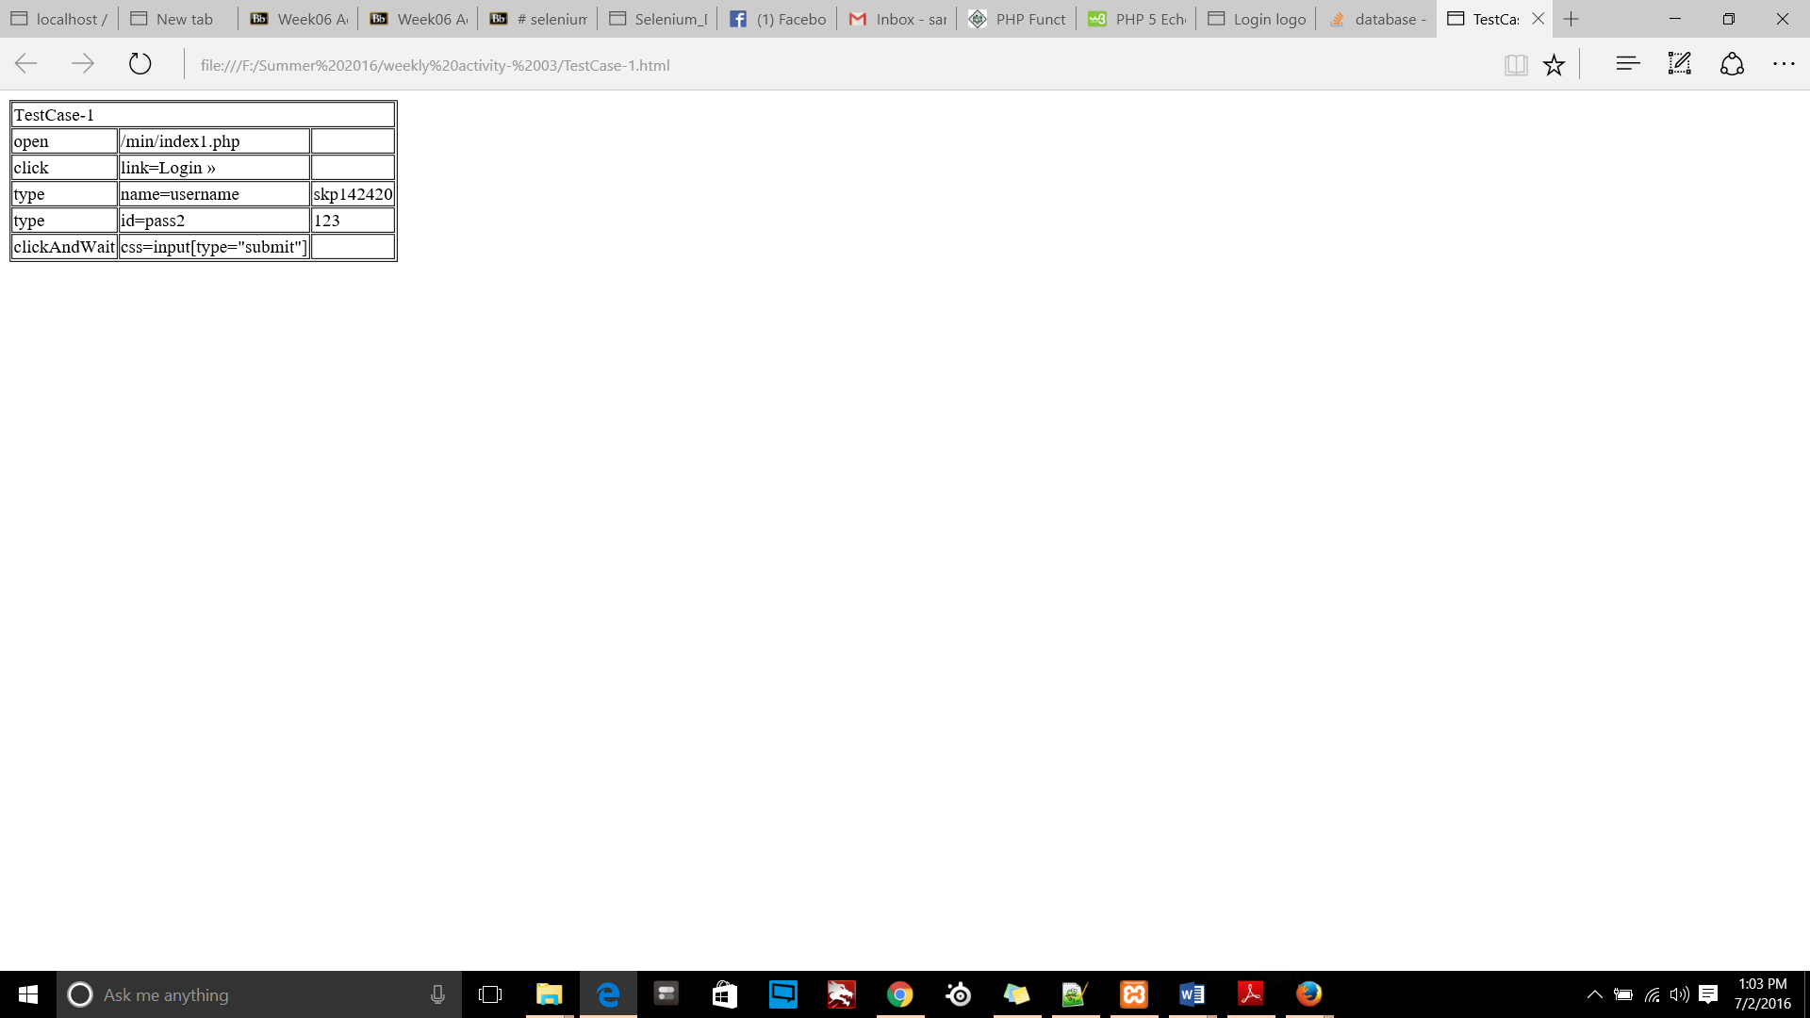

### Test Case-II (Logout)

Logout:

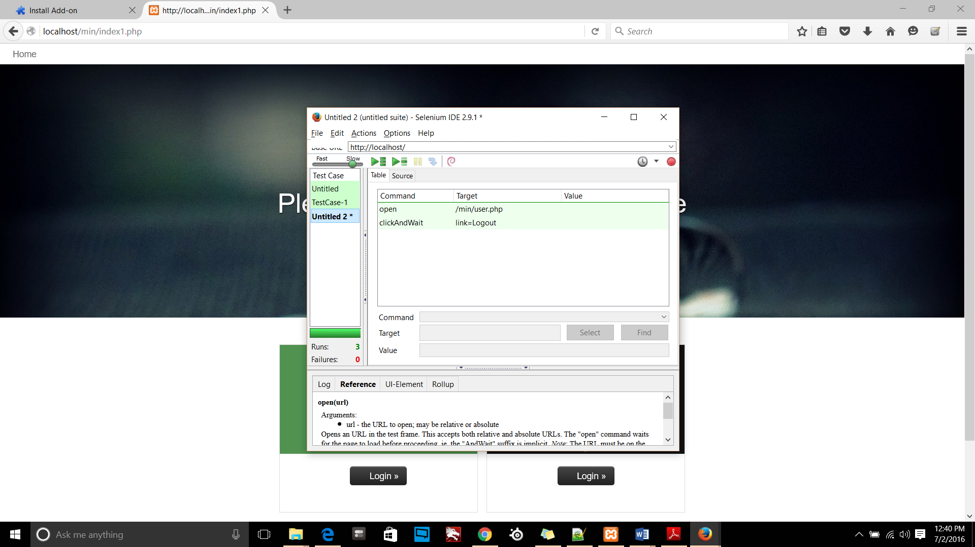

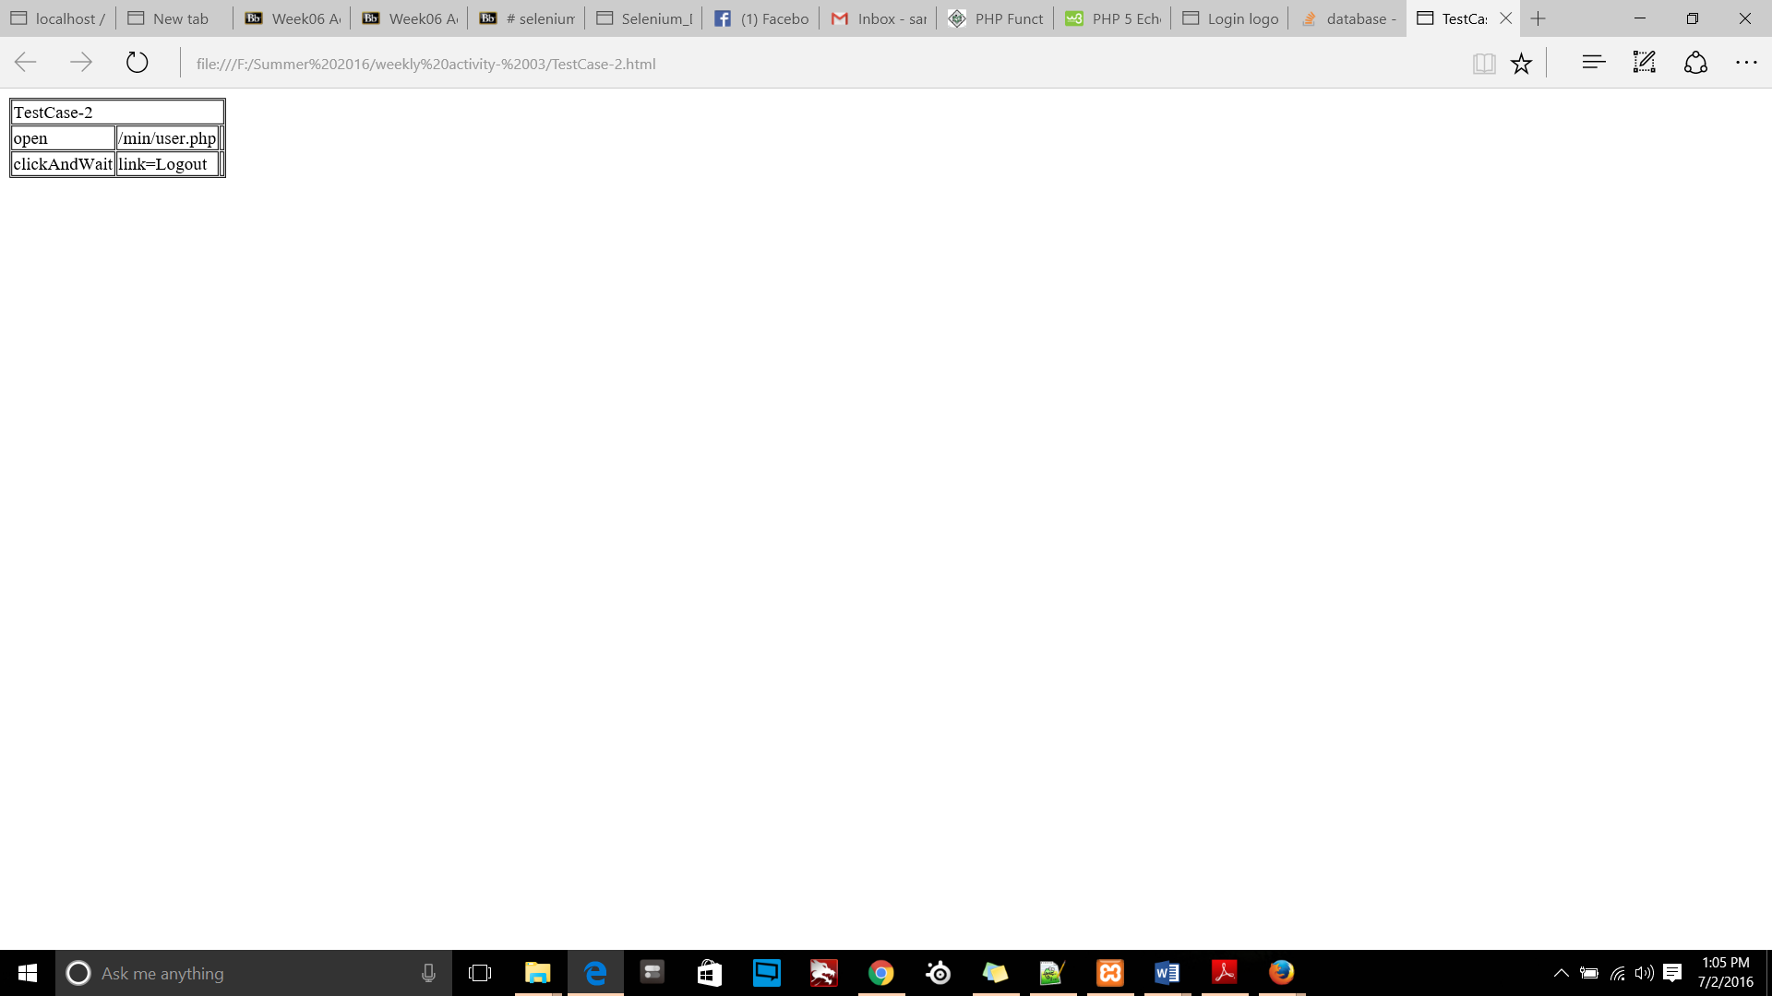

### Test Case-III (Registration)

User registration

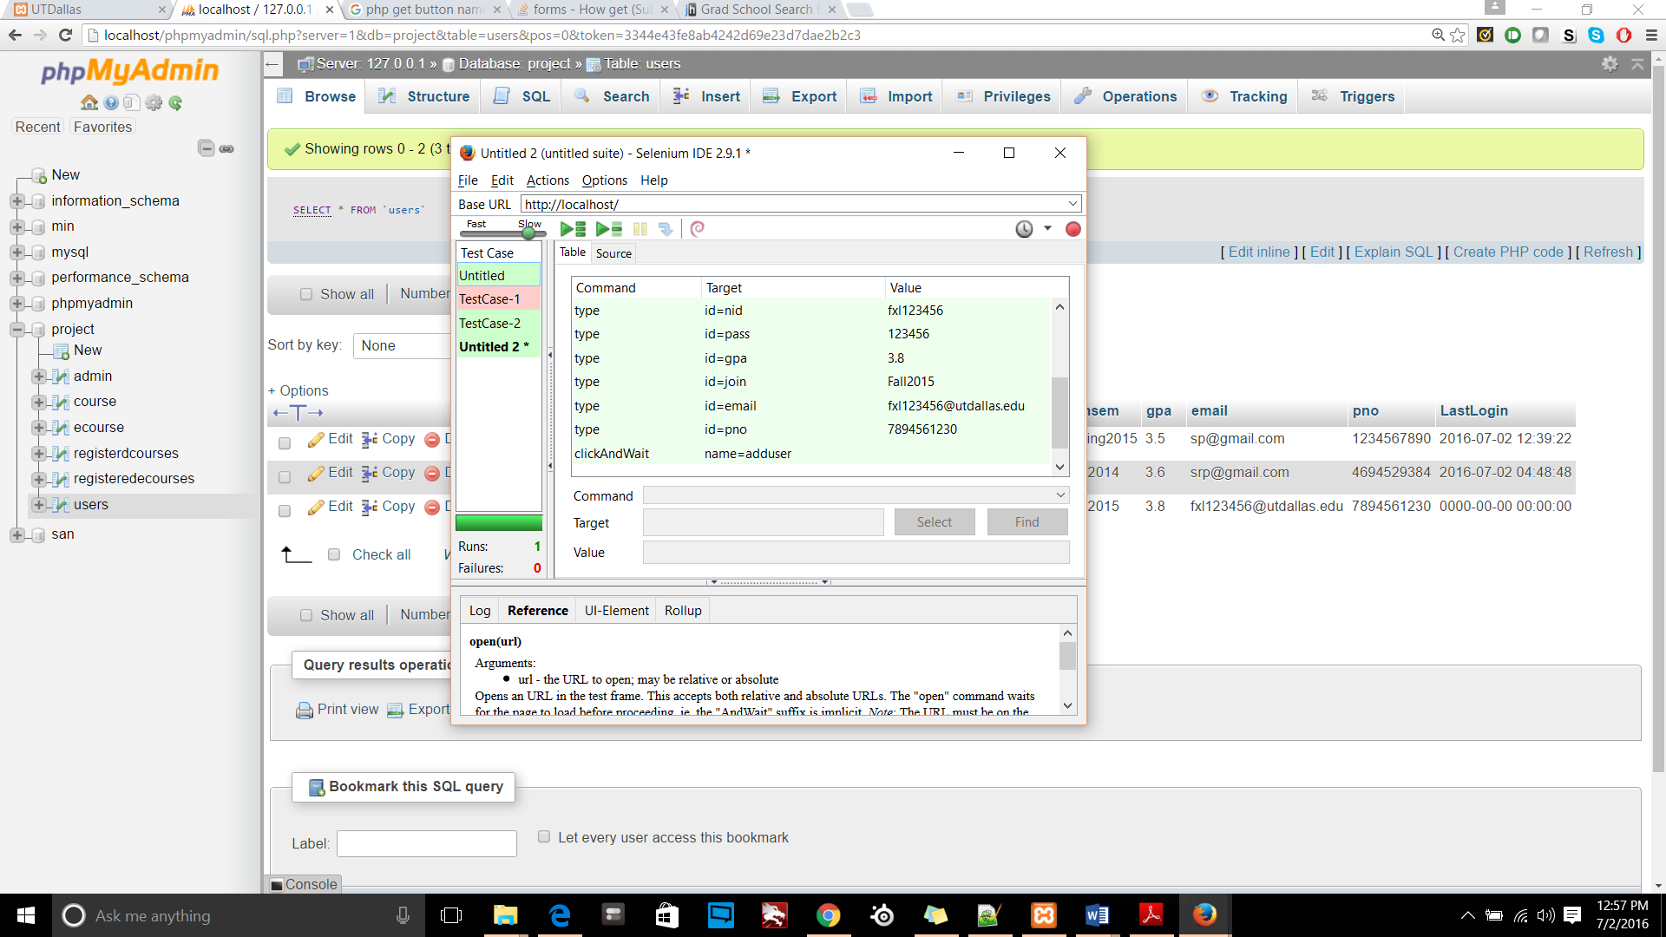

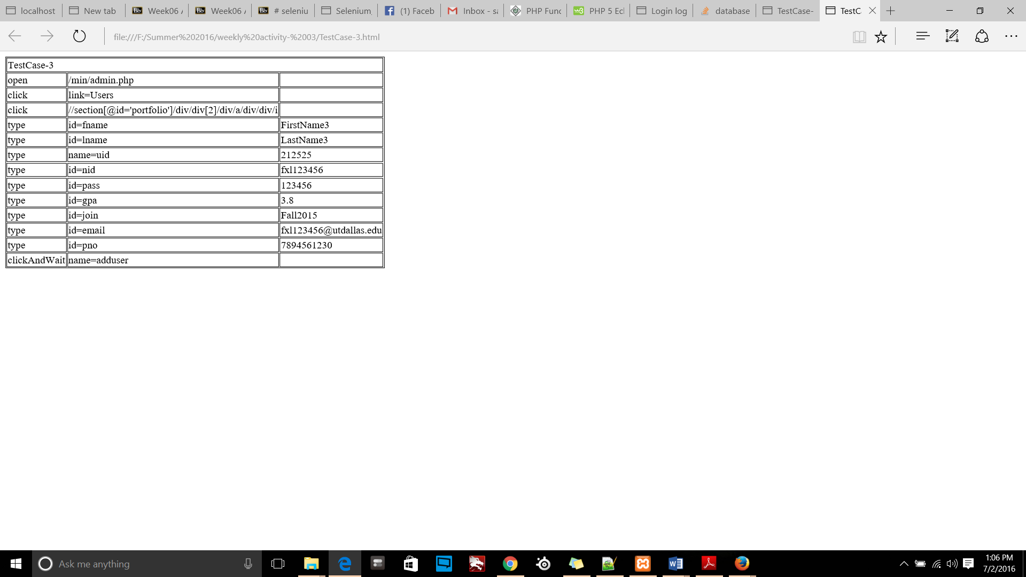

Course registration:

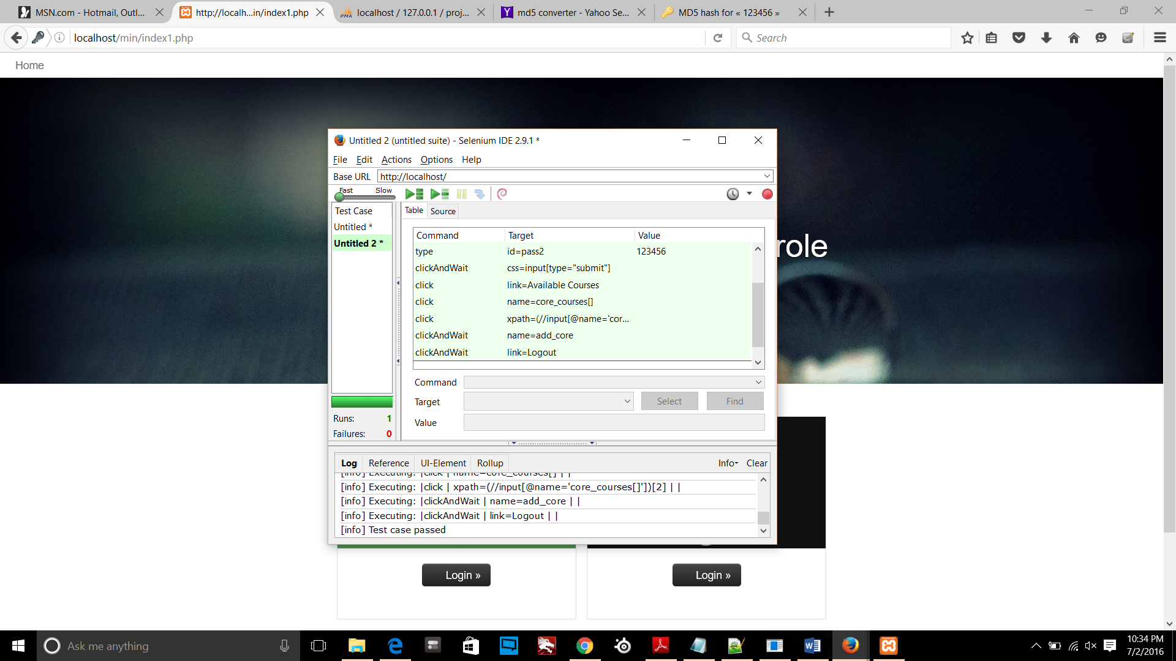

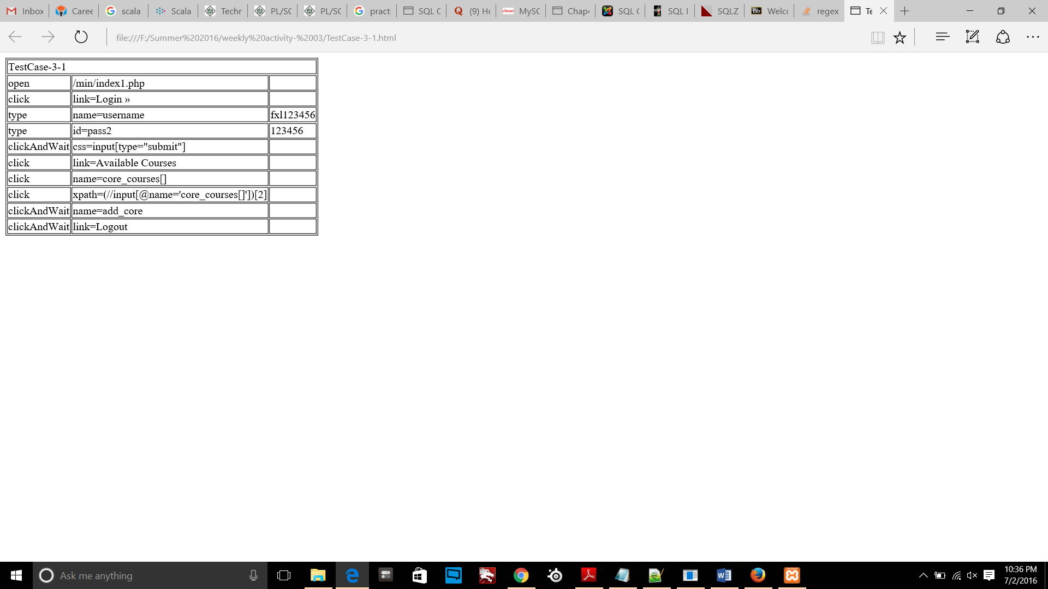

### Test Case-IV (Advisor availability)

Add timeslot as per availability for an advisor:

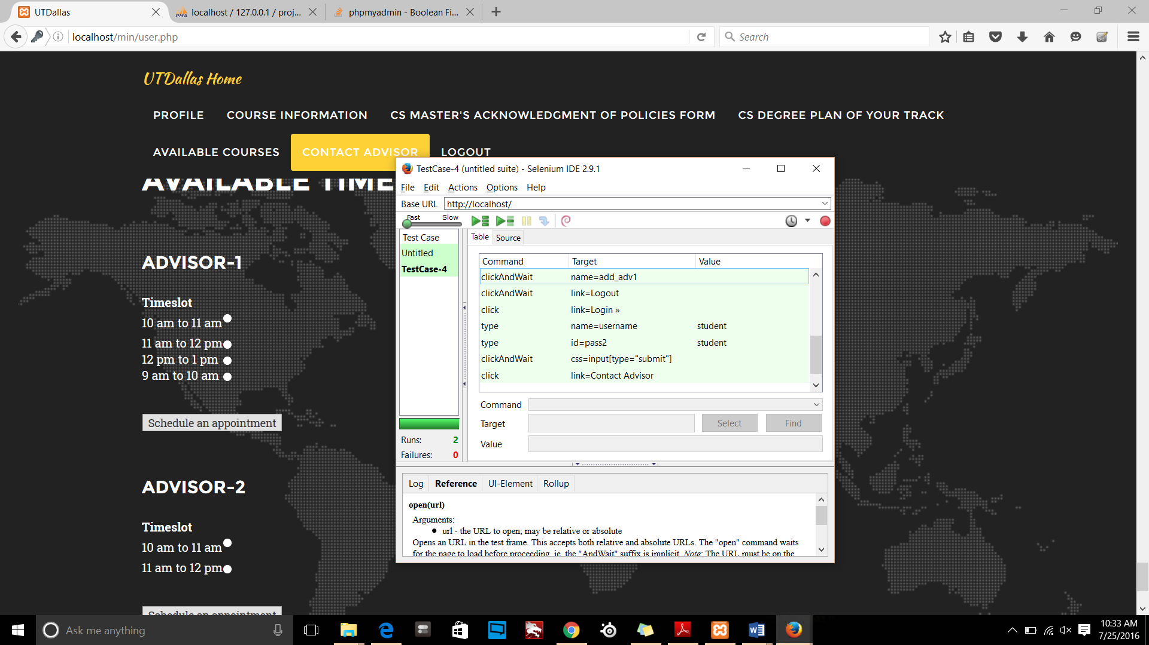

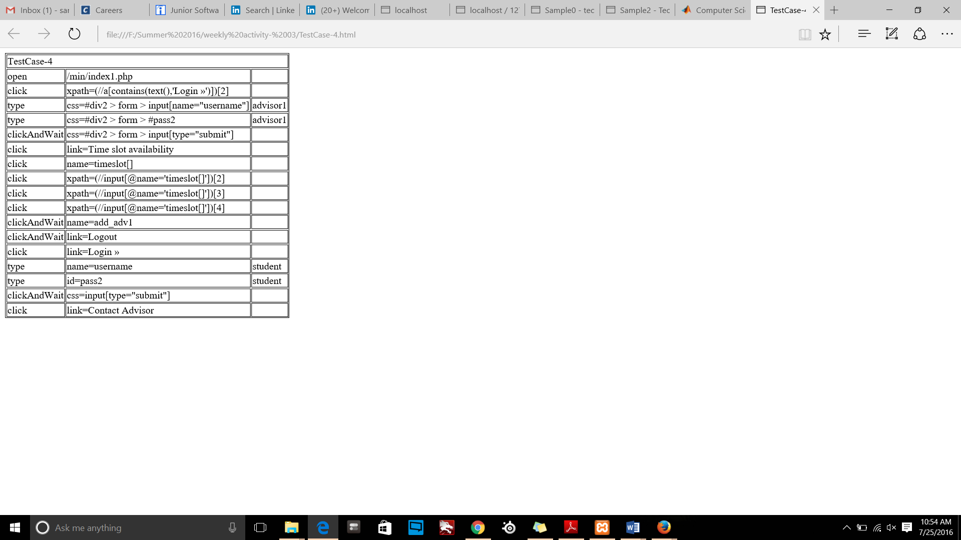

### Test Case-V (Add/delete Appointment by user)

Add/delete appointment by user

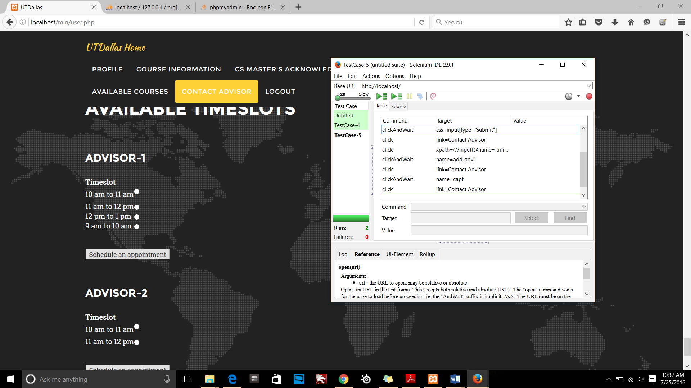

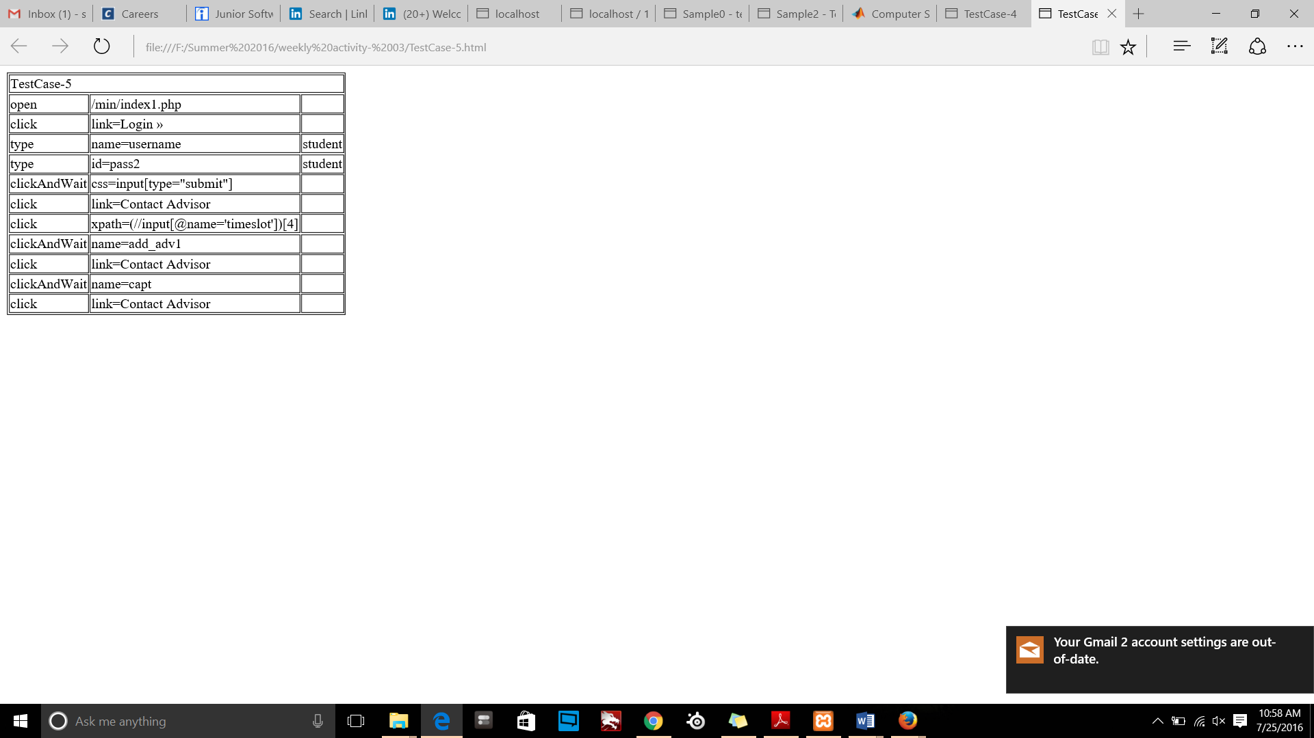

### Test Case-VI (Cancel scheduled appointment by advisor)

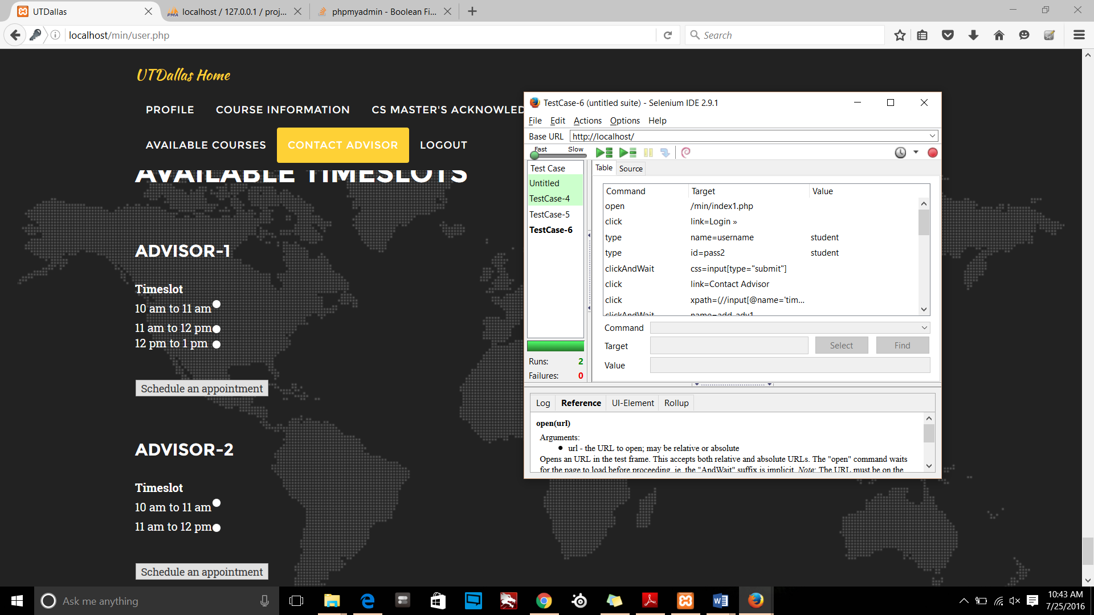

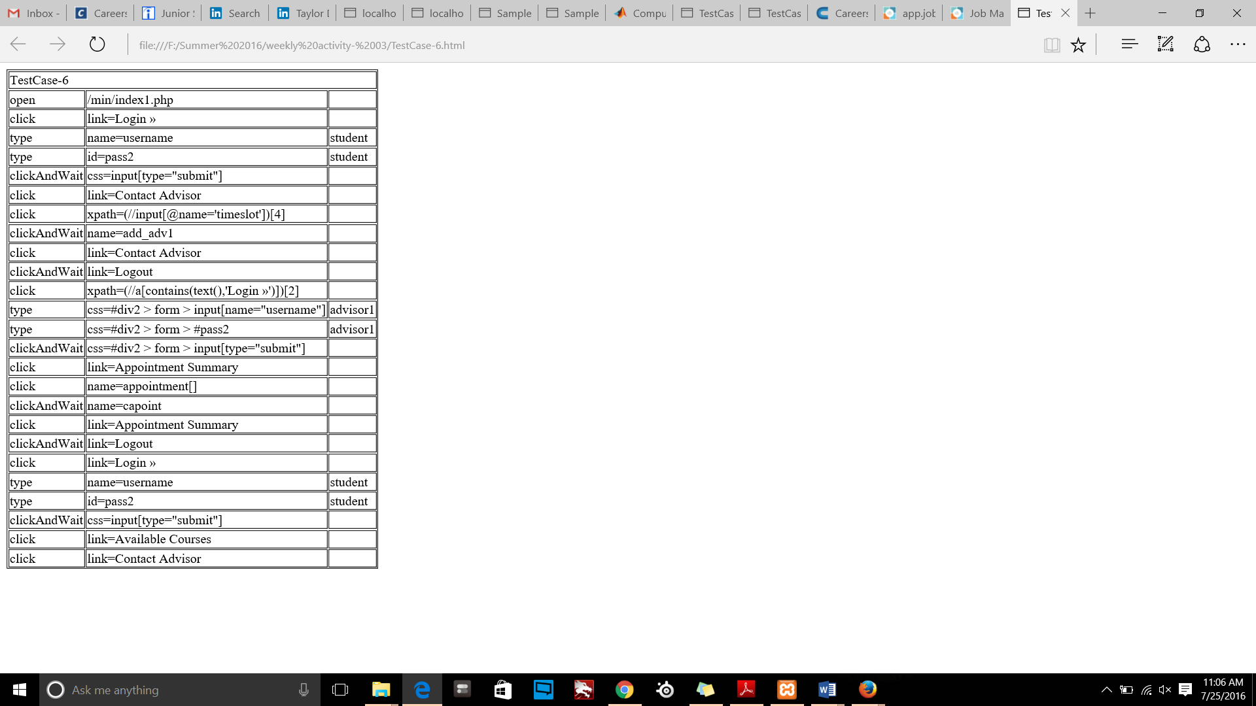

### Test Case-VII (Change of track)

Change track:

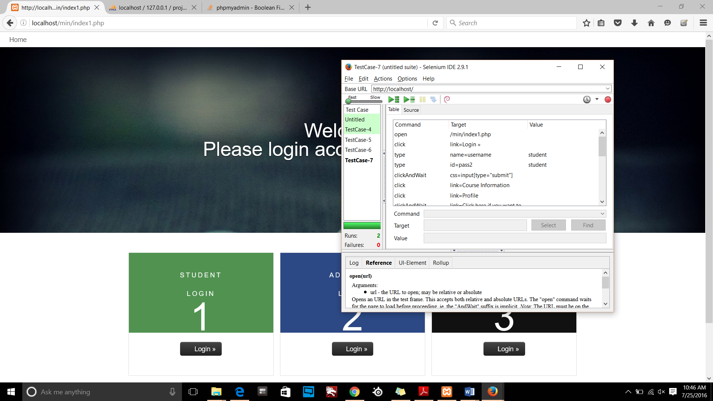

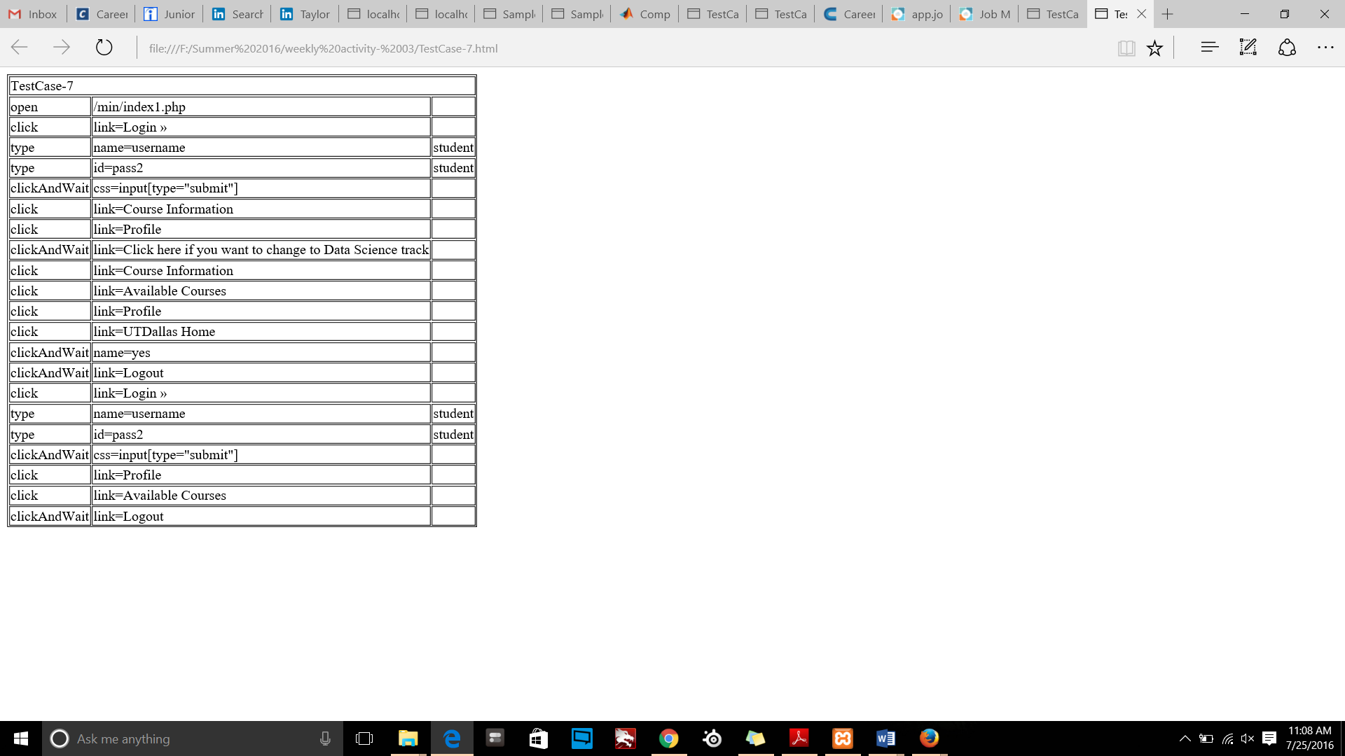

# User Interface

Degree Plan Implemented:

Track1: Data Science

Track2: Networks and Telecommunication.

You can get mail flow of this Project referring to screenshots

## Course Registration

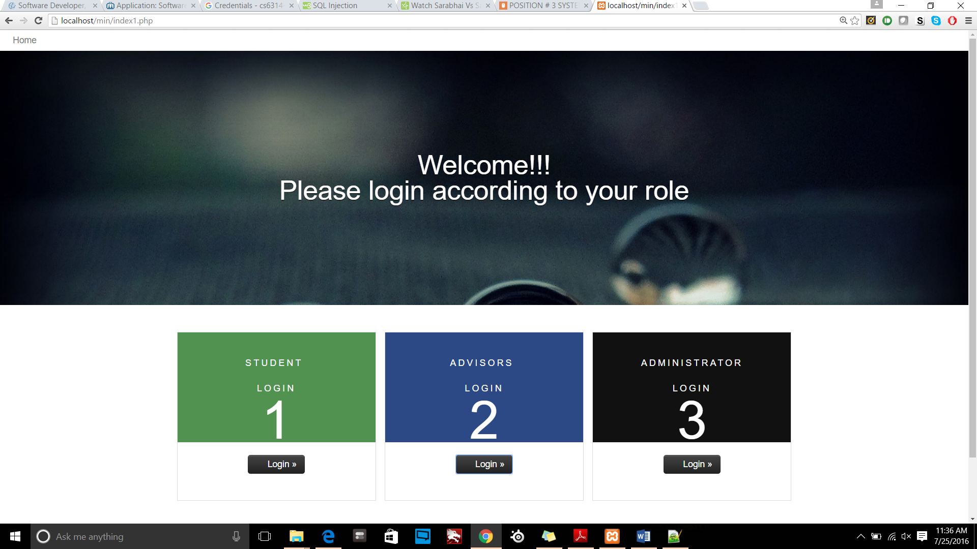

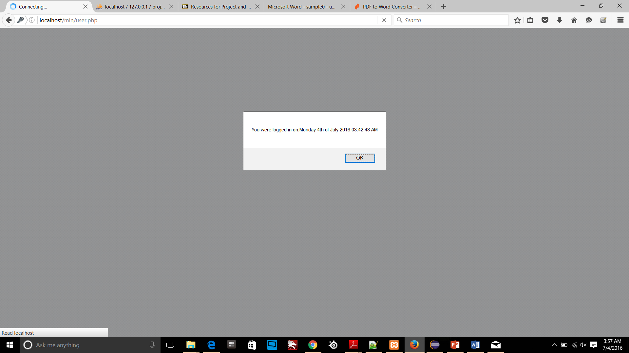

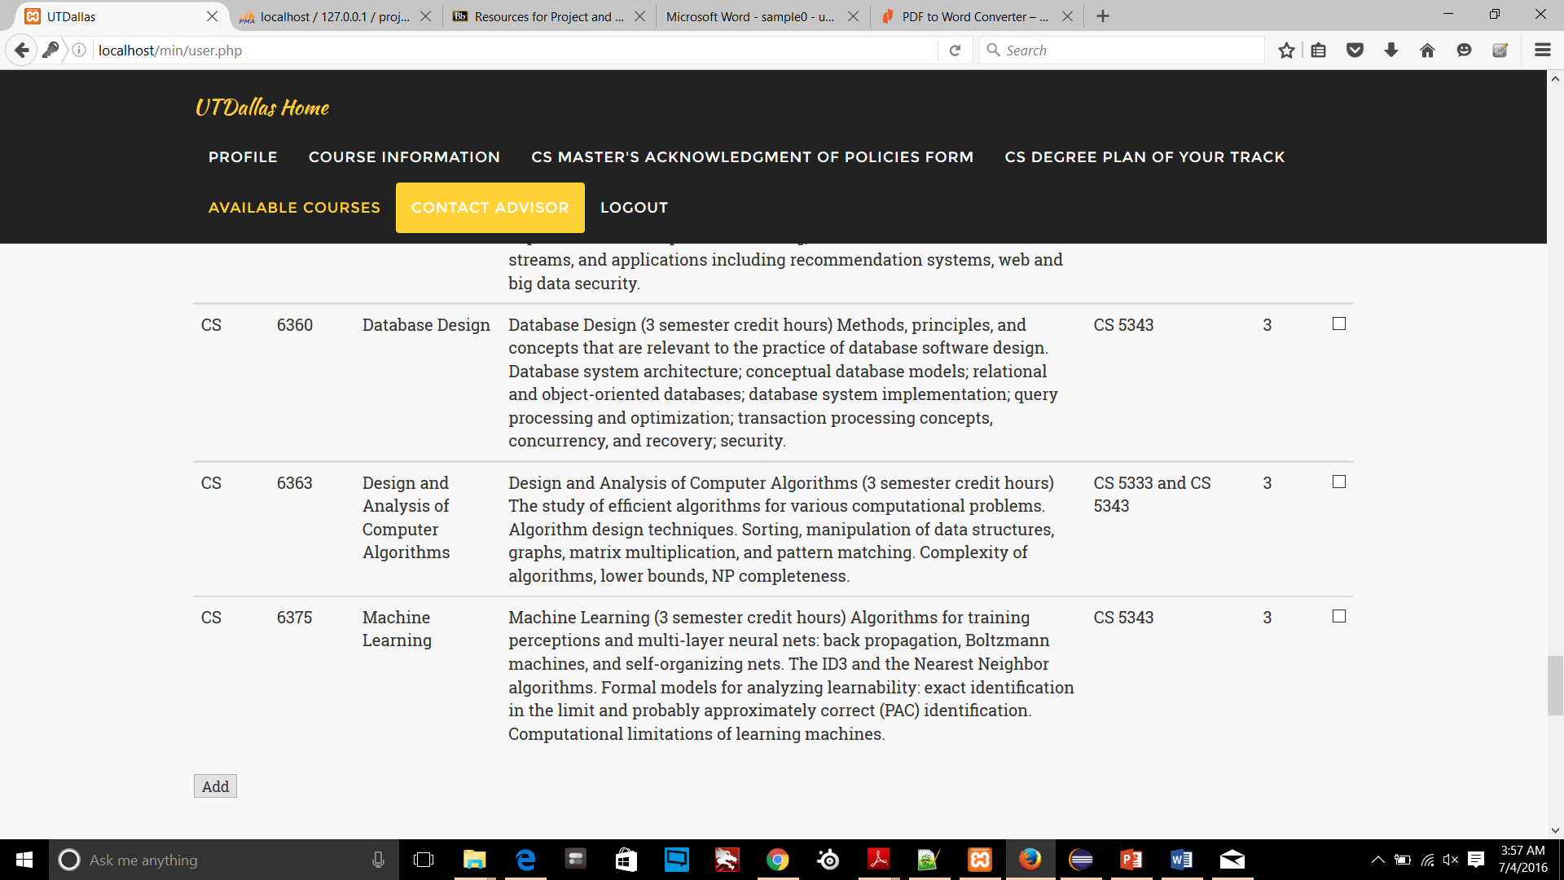

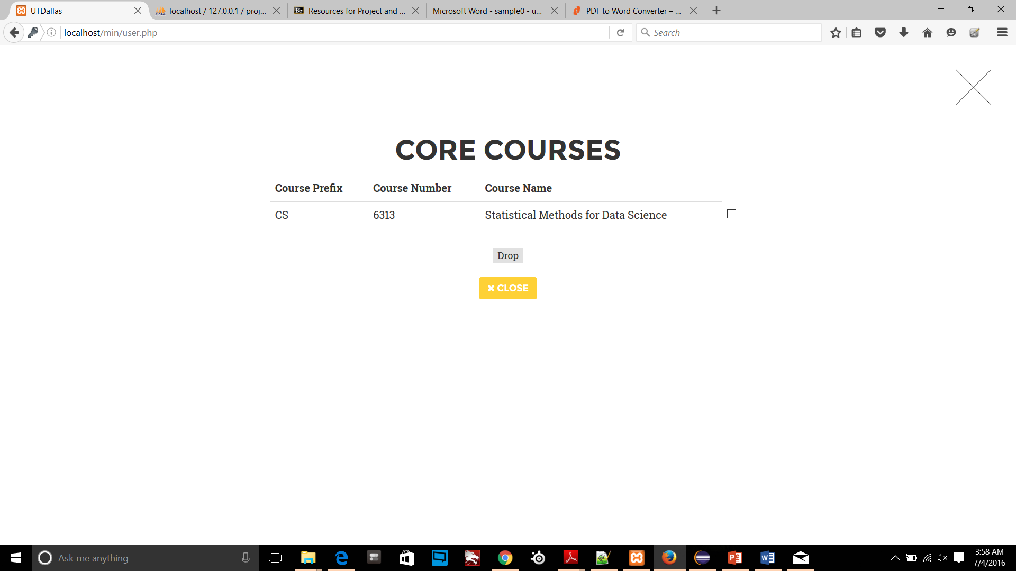

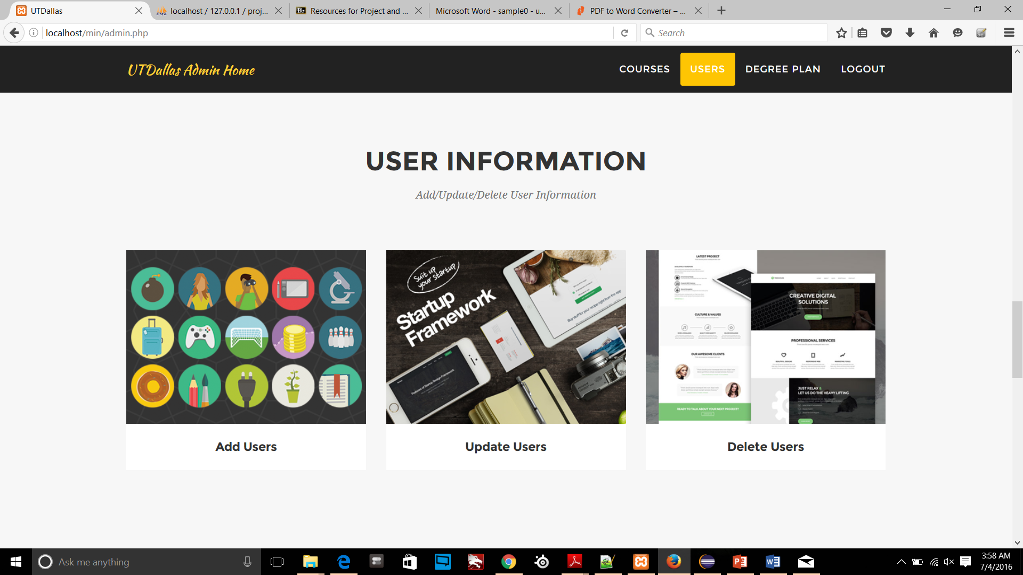

## Schedule an appointment with advisor

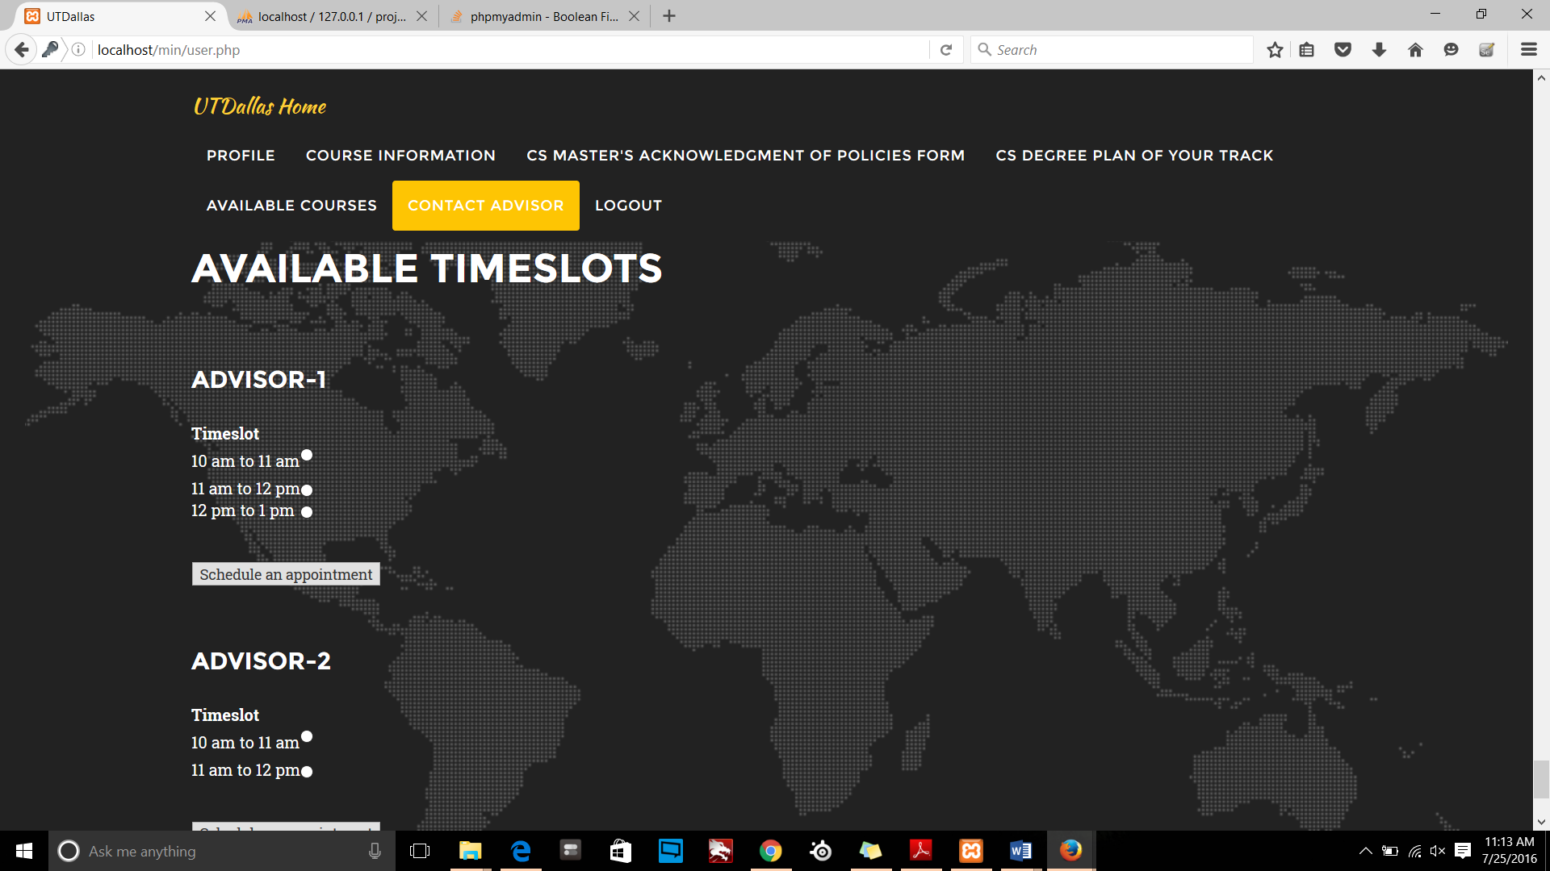

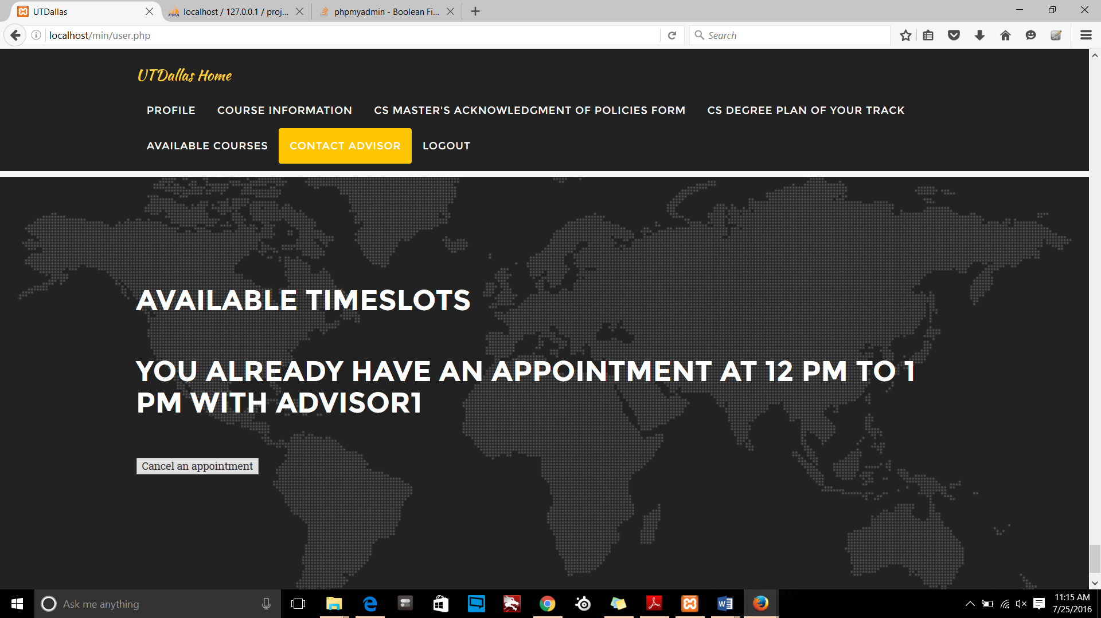

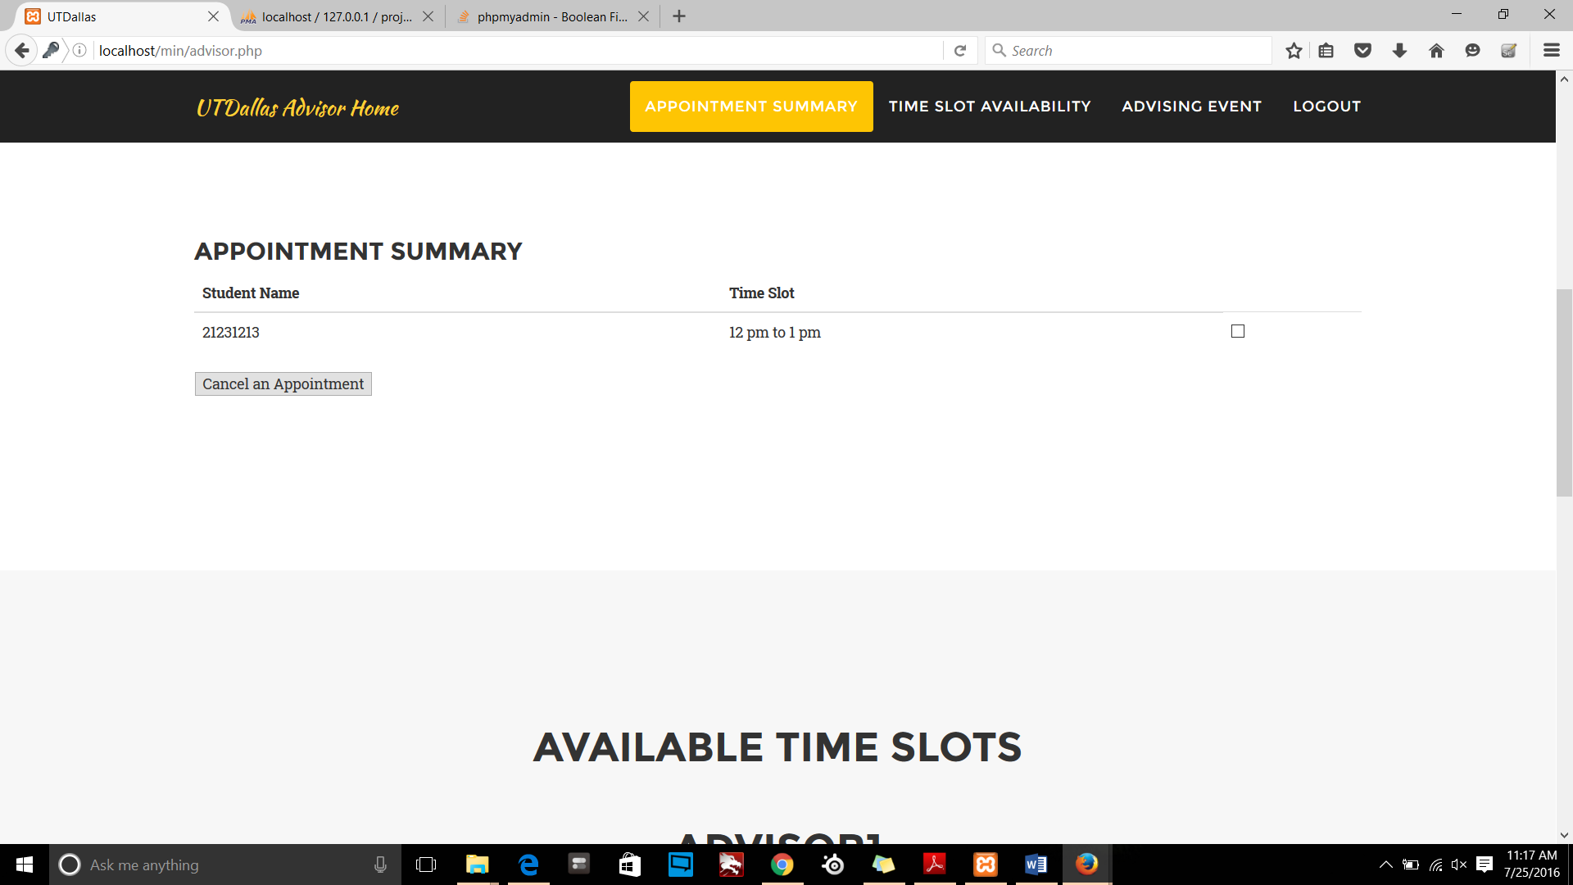

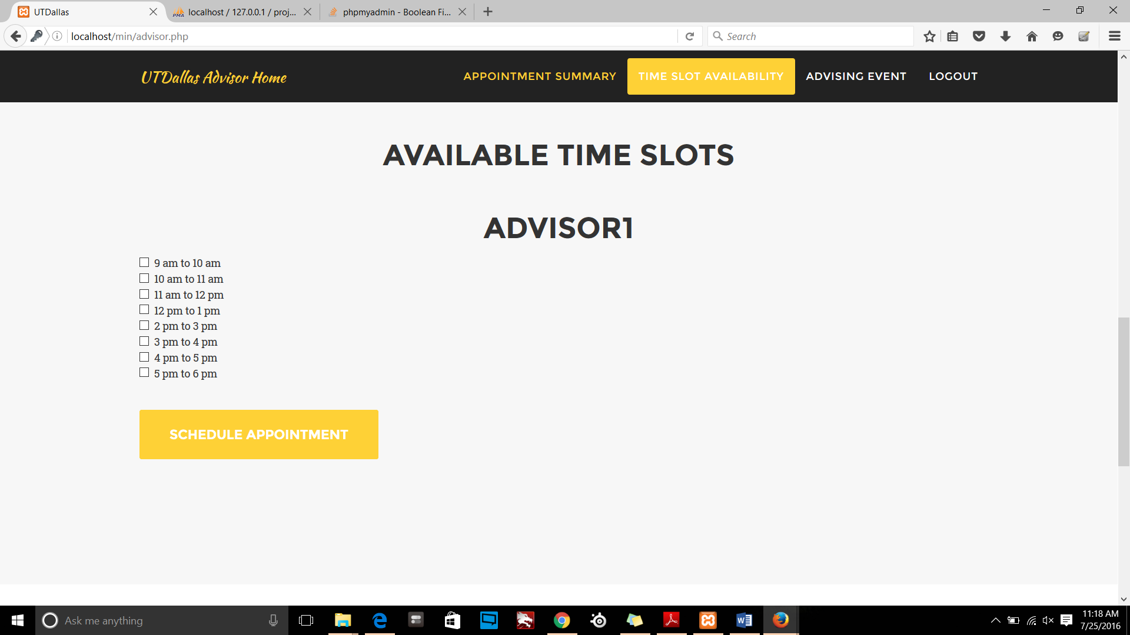

## Change of Track

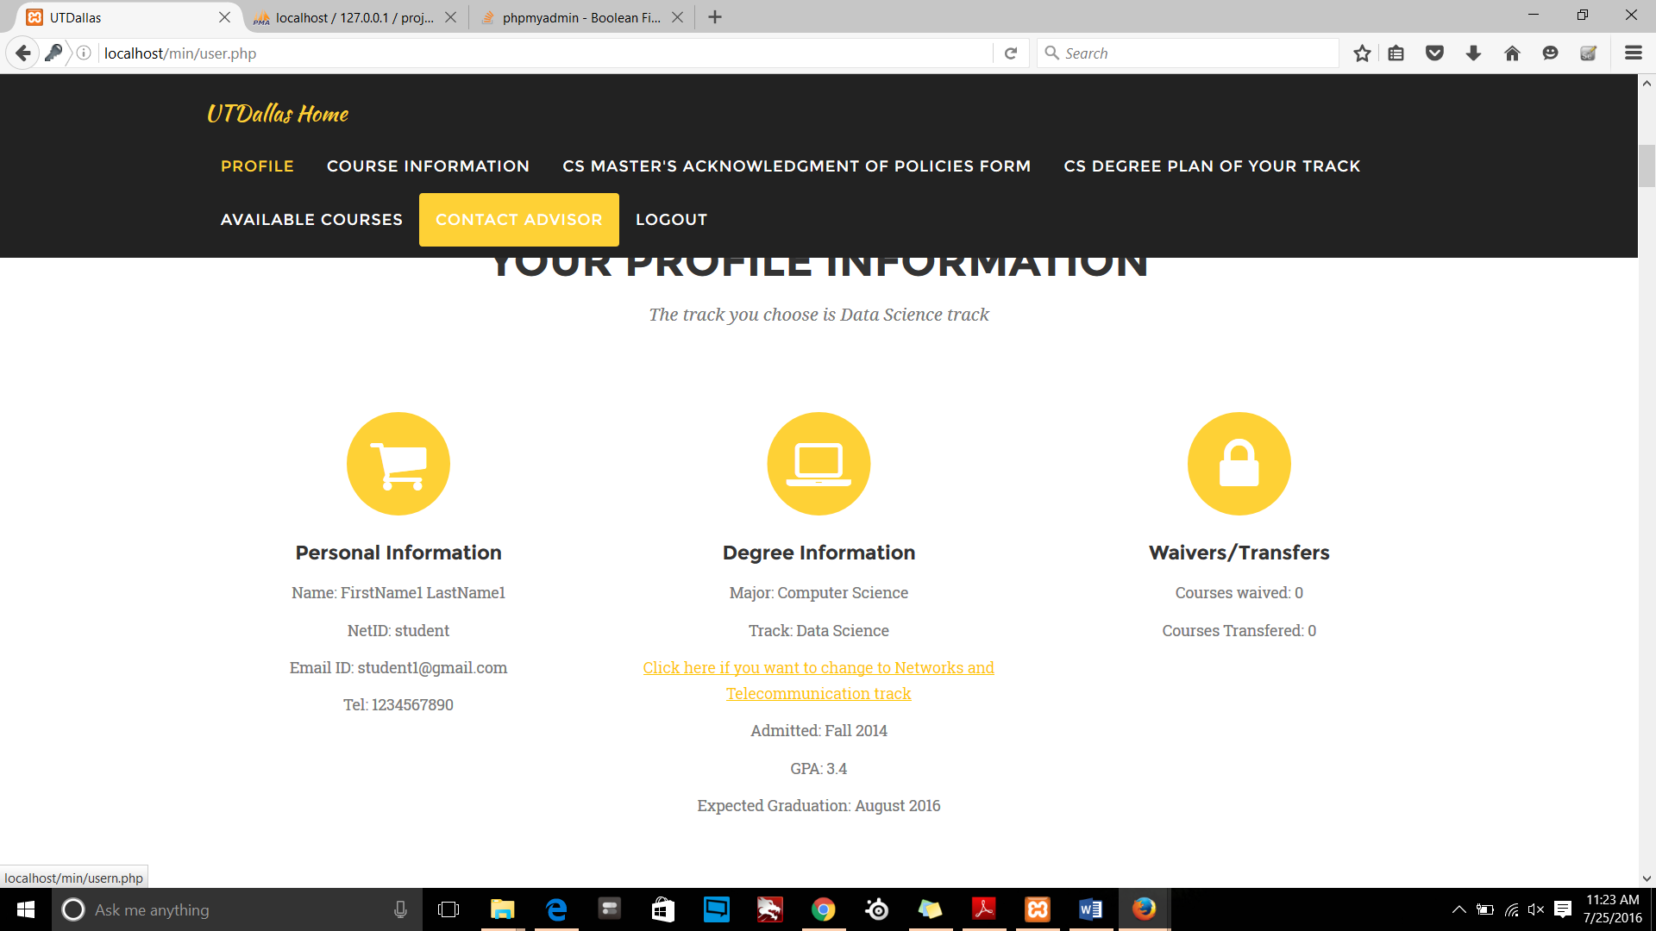

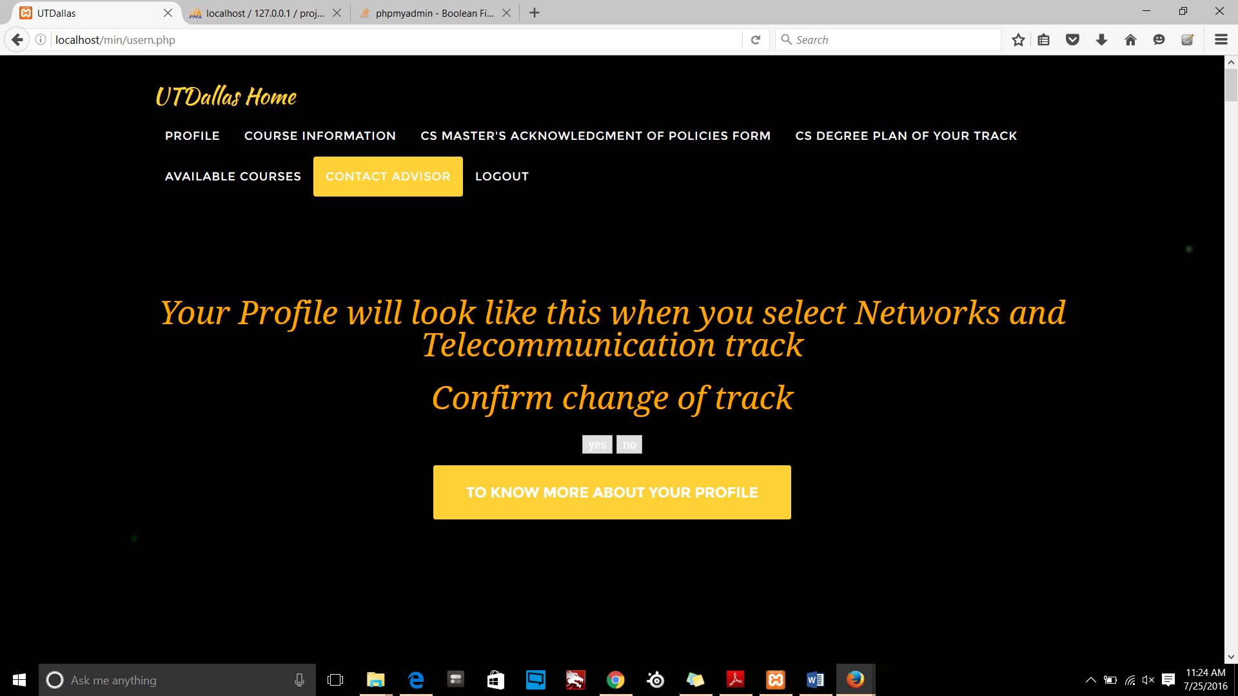

# Source code

## Index1.php

## User.php

## Admin.php

## Advisor.php

## Loginform.inc.php

//**Index1.php**

<!doctype html>

<html lang="en">

<head>

<meta charset="utf-8">

<meta charset="utf-8">

<meta name="viewport" content="width=device-width, initial-scale=1.0">

<meta name="description1" content="">

<meta name="author" content="">

<!-- Le styles -->

<link href="assets/css/bootstrap.css" rel="stylesheet">

<link href="assets/css/bootstrap-responsive.css" rel="stylesheet">

<meta name="viewport" content="width=device-width, initial-scale=1.0">

<meta name="description" content="A layout example that shows off a responsive pricing table.">

<link rel="stylesheet" href="http://yui.yahooapis.com/pure/0.4.2/pure.css">

<!--[if lte IE 8]>

<link rel="stylesheet" href="css/main-grid-old-ie.css">

<![endif]-->

<!--[if gt IE 8]><!-->

<link rel="stylesheet" href="css/main-grid.css">

<!--<![endif]-->

<!--[if lte IE 8]>

<link rel="stylesheet" href="css/layouts/pricing-old-ie.css">

<![endif]-->

<!--[if gt IE 8]><!-->

<link rel="stylesheet" href="css/layouts/pricing.css">

<!--<![endif]-->

</head>

<body>

<div class="pure-menu pure-menu-open pure-menu-horizontal">

<!-- <a href="#" class="pure-menu-heading">Your Logo</a> -->

<ul>

<li><a href="#">Home</a></li>

</ul>

</div>

<div class="banner">

<h1 class="banner-head">

Welcome!!!<br>

Please login according to your role

</h1>

</div>

<div class="l-content">

<div class="pricing-tables pure-g">

<div class="pure-u-1 pure-u-med-1-3">

<div class="pricing-table pricing-table-free">

<div class="pricing-table-header" >

<h2>Student <br>Login</h2><br>

<span class="pricing-table-price">

1

</span>

</div>

<br>

<div><a data-toggle="modal" href="#myModall" class="btn btn-inverse btn-medium"><i class="icon-pencil icon-white"></i> Login &raquo;</a></div>

<div id="myModall" class="modal hide fade"> <!-- in" role="dialog" aria-labelledby="myModalLabel" aria-hidden="true" fixed_managed="1" style="display: block;"> -->

<div class="modal-header">

<button type="button" class="close" data-dismiss="modal" aria-hidden="true">x</button>

<h3 id="myModalLabel" style="color:#08c">&nbsp Login Form</h3>

</div>

<div id="div1" class="modal-body">

</div>

<div class="modal-footer">

<button class="btn btn-inverse" data-dismiss="modal">Close</button>

</div>

</div>

</div>

</div>

<div class="pure-u-1 pure-u-med-1-3">

<div class="pricing-table pricing-table-biz pricing-table-selected">

<div class="pricing-table-header">

<h2>Advisors <br>Login</h2><br>

<span class="pricing-table-price">

2

</span>

</div>

<br>

<div><a data-toggle="modal" href="#myModall1" class="btn btn-inverse btn-medium"><i class="icon-pencil icon-white"></i> Login &raquo;</a></div>

<div id="myModall1" class="modal hide fade"> <!-- in" role="dialog" aria-labelledby="myModalLabel" aria-hidden="true" fixed_managed="1" style="display: block;"> -->

<div class="modal-header">

<button type="button" class="close" data-dismiss="modal" aria-hidden="true">x</button>

<h3 id="myModalLabel" style="color:#08c">&nbsp Login Form</h3>

</div>

<div id="div2" class="modal-body">

</div>

<div class="modal-footer">

<button class="btn btn-inverse" data-dismiss="modal">Close</button>

</div>

</div>

</div>

</div>

<div class="pure-u-1 pure-u-med-1-3">

<div class="pricing-table pricing-table-enterprise">

<div class="pricing-table-header">

<h2>Administrator<br> Login</h2> <br>

<span class="pricing-table-price">

3

</span>

</div>

<br>

<div><a data-toggle="modal" href="#myModall2" class="btn btn-inverse btn-medium"><i class="icon-pencil icon-white"></i> Login &raquo;</a></div>

<div id="myModall2" class="modal hide fade" > <!-- in" role="dialog" aria-labelledby="myModalLabel" aria-hidden="true" fixed_managed="1" style="display: block;">-->

<div class="modal-header">

<button type="button" class="close" data-dismiss="modal" aria-hidden="true">x</button>

<h3 id="myModalLabel" style="color:#08c">&nbsp Login Form</h3>

</div>

<div id="div3" class="modal-body" >

</div>

<div class="modal-footer">

<button class="btn btn-inverse" data-dismiss="modal">Close</button>

</div>

</div>

</div>

</div>

</div>

</div> <!-- end l-content -->

<footer>

<div class="footer l-box">

<div class="row">

<div class="col-md-4">

<span class="copyright">Copyright &copy; Sanket Prabhu 2016</span>

</div>

</div>

</div>

</footer>

<div class="footer l-box">

<p>

<a href="#"></a> <a href='http://unsplash.com/'></a>.

</p>

</div>

<script src="assets/js/jquery.js"></script>

<script src="assets/js/bootstrap-transition.js"></script>

<script src="assets/js/bootstrap-alert.js"></script>

<script src="assets/js/bootstrap-modal.js"></script>

<script src="assets/js/bootstrap-dropdown.js"></script>

<script src="assets/js/bootstrap-scrollspy.js"></script>

<script src="assets/js/bootstrap-tab.js"></script>

<script src="assets/js/bootstrap-tooltip.js"></script>

<script src="assets/js/bootstrap-popover.js"></script>

<script src="assets/js/bootstrap-button.js"></script>

<script src="assets/js/bootstrap-collapse.js"></script>

<script src="assets/js/bootstrap-carousel.js"></script>

<script src="assets/js/bootstrap-typeahead.js"></script>

<script type="text/javascript">

$("#div1").load("index.php");

$("#div2").load("index3.php");

$("#div3").load("index2.php");

</script>

</body>

</html>

<?php

require 'core.inc.php';

require 'connect.inc.php';

//echo 'you are logged IN.<a href="logout.php" >Log out.</a><br>';

$field = 'fname';

$lfield = 'lname';

$nfield = 'nid';

$efield = 'email';

$pfield = 'pno';

$afield = 'joinsem';

$gfield = 'gpa';

$datetime = 'LastLogin';

$name = getuserfield($field);

$dtime = getuserfield($datetime);

$result1 = gettime();

$tr = 'track';

$id = 'tid';

$track = 'Data Science';

$track1 = 'Networks and Telecommunication';

$trid = gettrack($id);

$cookie_name = "last_login_time";

if(!isset($_COOKIE[$cookie_name])){

} else{

echo "<script type='text/javascript'> alert('You were logged in on:".$_COOKIE[$cookie_name]."');</script>";

}

// echo "<script type='text/javascript'> alert('here');</script>";

if(isset($_POST["yes"])){

$servername = "localhost";

$username = "root";

$password = "";

$dbname = "project";

$conn = new mysqli($servername, $username, $password, $dbname);

if ($conn->connect_error) {

die("Connection failed: " . $conn->connect_error);

}

$t = gettrack($tr);

if(strcmp($track,$t)){

// echo "<script type='text/javascript'> alert('inside if');</script>";

$query = "UPDATE usertrack SET track='".$track."', tid='d'

WHERE `username` ='". $_SESSION['user_id']."'";

$result = mysql_query($query);

}

else{

// echo "<script type='text/javascript'> alert('inside else');</script>";

$query = "UPDATE usertrack SET track='".$track1."', tid='n'

WHERE `username` ='". $_SESSION['user_id']."'";

$result = mysql_query($query);

}

}

$servername = "localhost";

$username = "root";

$password = "";

$dbname = "project";

$conn = new mysqli($servername, $username, $password, $dbname);

if ($conn->connect_error) {

die("Connection failed: " . $conn->connect_error);

} /*

$sql = "SELECT cname, cnum, cpref, cdes, prereq, credits FROM course";

$result = $conn->query($sql);

if ($result->num_rows > 0) {

while($row = $result->fetch_assoc()) {

$row1 = $row["cnum"];*/

// echo "<script type='text/javascript'> alert('$bname');</script>";

//$bname = $_POST['id']; if(isset($_POST["add_core"])){

// echo "<script type='text/javascript'> alert('Records inserted succesfully..');</script>";

//

echo "<script type='text/javascript'> alert('Hi $bname');</script>";

get_course_from_checkboxes($_POST["core_courses"]) ;

if(isset($_POST["add_elective"])){

// echo "<script type='text/javascript'> alert('Records inserted succesfully..');</script>";

// echo "<script type='text/javascript'> alert('Hi $bname');</script>";

get_course_from_checkboxes1($_POST["elective_courses"]) ;

if(isset($_POST["drop_core"])){

// echo "<script type='text/javascript'> alert('Records inserted succesfully..');</script>";

// echo "<script type='text/javascript'> alert('Hi $bname');</script>";

get_course_from_checkboxes2($_POST["core_courses1"]) ;

if(isset($_POST["drop_elective"])){

// echo "<script type='text/javascript'> alert('Records inserted succesfully..');</script>";

// echo "<script type='text/javascript'> alert('Hi $bname');</script>";

get_course_from_checkboxes3($_POST["elective_courses1"]) ;

function get_course_from_checkboxes($core_courses){

if(isset($core_courses)){

//Inserting data in user_classes table

if(count($core_courses) >0){

// echo "<table><caption>Core courses registered now </caption><tr> <th>Course Prefix </th> <th>Course Name </th> <th>Number of Credit Hours </th></tr>";

foreach ($core_courses as $key => $value) {

// echo $value;

$servername = "localhost";

$username = "root";

$password = "";

$dbname = "project";

$conn = new mysqli($servername, $username, $password, $dbname);

if ($conn->connect_error) {

die("Connection failed: " . $conn->connect_error);

}

$sql = "Insert into registerdcourses values('".$_SESSION['user_id']."','".$value."')";

if ($query_run1 = mysql_query($sql)) {

echo "<script type='text/javascript'> alert('Courses added succesfully..');</script>";

// header('Location:admin.php');

}

else {

echo "<script type='text/javascript'> alert('You have already registered the course');</script>";

// $conn->query($sql);

// echo "</tr>";

}

// echo "</table>";

}

// echo "<br/>";

}

$conn->close();

}

}

function get_course_from_checkboxes2($core_courses1){

if(isset($core_courses1)){

//Inserting data in user_classes table

if(count($core_courses1) >0){

// echo "<table><caption>Core courses registered now </caption><tr> <th>Course Prefix </th> <th>Course Name </th> <th>Number of Credit Hours </th></tr>";

foreach ($core_courses1 as $key => $value) {

// echo $value;

$servername = "localhost";

$username = "root";

$password = "";

$dbname = "project";

$conn = new mysqli($servername, $username, $password, $dbname);

if ($conn->connect_error) {

die("Connection failed: " . $conn->connect_error);

}

$sql = "Delete from registerdcourses where uid='".$_SESSION['user_id']."' and cnum='".$value."'";

if ($query_run1 = mysql_query($sql)) {

echo "<script type='text/javascript'> alert('Courses deleted succesfully..');</script>";

// header('Location:admin.php');

}

else {

echo "<script type='text/javascript'> alert('You have already registered the course');</script>";

// $conn->query($sql);

// echo "</tr>";

}

// echo "</table>";

}

// echo "<br/>";

}

$conn->close();

}

}

function get_course_from_checkboxes1($elective_courses){

if(isset($elective_courses)){

//Inserting data in user_classes table

if(count($elective_courses) >0){

// echo "<table><caption>Core courses registered now </caption><tr> <th>Course Prefix </th> <th>Course Name </th> <th>Number of Credit Hours </th></tr>";

foreach ($elective_courses as $key => $value) {

// echo $value;

$servername = "localhost";

$username = "root";

$password = "";

$dbname = "project";

$conn = new mysqli($servername, $username, $password, $dbname);

if ($conn->connect_error) {

die("Connection failed: " . $conn->connect_error);

}

$sql = "Insert into registeredecourses values('".$_SESSION['user_id']."','".$value."')";

if ($query_run1 = mysql_query($sql)) {

echo "<script type='text/javascript'> alert('Courses added succesfully..');</script>";

// header('Location:admin.php');

}

else {

echo "<script type='text/javascript'> alert('You have already registered the course');</script>";

// $conn->query($sql);

// echo "</tr>";

}

// echo "</table>";

}

// echo "<br/>";

}

$conn->close();

}

}

function get_course_from_checkboxes3($elective_courses1){

if(isset($elective_courses1)){

//Inserting data in user_classes table

if(count($elective_courses1) >0){

// echo "<table><caption>Core courses registered now </caption><tr> <th>Course Prefix </th> <th>Course Name </th> <th>Number of Credit Hours </th></tr>";

foreach ($elective_courses1 as $key => $value) {

// echo $value;

$servername = "localhost";

$username = "root";

$password = "";

$dbname = "project";

$conn = new mysqli($servername, $username, $password, $dbname);

if ($conn->connect_error) {

die("Connection failed: " . $conn->connect_error);

}

$sql = "Delete from registeredecourses where uid='".$_SESSION['user_id']."' and ecnum='".$value."'";

if ($query_run1 = mysql_query($sql)) {

echo "<script type='text/javascript'> alert('Courses deleted succesfully..');</script>";

// header('Location:admin.php');

}

else {

echo "<script type='text/javascript'> alert('You have already registered the course');</script>";

// $conn->query($sql);

// echo "</tr>";

}

// echo "</table>";

}

// echo "<br/>";

}

$conn->close();

}

}

if(isset($_POST['add_adv1'])){

if(isset($_POST['timeslot'])){

$var = $_POST['timeslot'];

echo "<script type='text/javascript'> alert('You have $var');</script>";

$servername = "localhost";

$username = "root";

$password = "";

$dbname = "project";

$conn = new mysqli($servername, $username, $password, $dbname);

if ($conn->connect_error) {

die("Connection failed: " . $conn->connect_error);

}

$sql = "Insert into regtslot values('".$_SESSION['user_id']."','".$var."','advisor1')";

if ($query_run1 = mysql_query($sql)) {

echo "<script type='text/javascript'> alert('Appointment made succesfully..');</script>";

header('Location:user.php');

}

else {

echo "<script type='text/javascript'> alert('You have already added timeslot');</script>";

// $conn->query($sql);

// echo "</tr>";

}

$sql = "Delete from advapt where id='advisor1' and timeslots='".$var."'";

// echo "</table>";

if ($query_run1 = mysql_query($sql)) {

echo "<script type='text/javascript'> alert('Appointment made succesfully..');</script>";

header('Location:user.php');

}

else {

echo "<script type='text/javascript'> alert('You have already added timeslot');</script>";

// $conn->query($sql);

// echo "</tr>";

}

// echo "<br/>";

$conn->close();

}

}

if(isset($_POST['add_adv2'])){

if(isset($_POST['timeslot1'])){

$var = $_POST['timeslot1'];

echo "<script type='text/javascript'> alert('You have $var');</script>";

$servername = "localhost";

$username = "root";

$password = "";

$dbname = "project";

$conn = new mysqli($servername, $username, $password, $dbname);

if ($conn->connect_error) {

die("Connection failed: " . $conn->connect_error);

}

$sql = "Insert into regtslot values('".$_SESSION['user_id']."','".$var."','advisor2')"; if ($query_run1 = mysql_query($sql)) {

echo "<script type='text/javascript'> alert('Appointment made succesfully..');</script>";

header('Location:user.php');

}

else {

echo "<script type='text/javascript'> alert('You have already added timeslot');</script>";

// $conn->query($sql);

// echo "</tr>";

}

$sql = "Delete from advapt where id='advisor2' and timeslots='".$var."'";

// echo "</table>";

if ($query_run1 = mysql_query($sql)) {

echo "<script type='text/javascript'> alert('Appointment made succesfully..');</script>";

header('Location:user.php');

}

else {

echo "<script type='text/javascript'> alert('You have already added timeslot');</script>";

// $conn->query($sql);

// echo "</tr>";

}

// echo "<br/>";

$conn->close();

}

}

?>

<script type="text/javascript">

function addCourse(name){

//var x = document.getElementById("button").name;

// alert('Button '+name);

}

</script>

<!DOCTYPE html>

<html lang="en">

<head>

<meta charset="utf-8">

<meta http-equiv="X-UA-Compatible" content="IE=edge">

<meta name="viewport" content="width=device-width, initial-scale=1">

<meta name="description" content="">

<meta name="author" content="">

<title>UTDallas</title>

<meta name="viewport" content="width=device-width, initial-scale=1">

<link rel="stylesheet" href="http://maxcdn.bootstrapcdn.com/bootstrap/3.3.6/css/bootstrap.min.css">

<script src="https://ajax.googleapis.com/ajax/libs/jquery/1.12.2/jquery.min.js"></script>

<script src="http://maxcdn.bootstrapcdn.com/bootstrap/3.3.6/js/bootstrap.min.js"></script>

<!-- Bootstrap Core CSS -->

<link href="css/bootstrap.min.css" rel="stylesheet">

<!-- Custom CSS -->

<link href="css/agency.css" rel="stylesheet">

<!-- Custom Fonts -->

<link href="font-awesome/css/font-awesome.min.css" rel="stylesheet" type="text/css">

<link href="https://fonts.googleapis.com/css?family=Montserrat:400,700" rel="stylesheet" type="text/css">

<link href='https://fonts.googleapis.com/css?family=Kaushan+Script' rel='stylesheet' type='text/css'>

<link href='https://fonts.googleapis.com/css?family=Droid+Serif:400,700,400italic,700italic' rel='stylesheet' type='text/css'>

<link href='https://fonts.googleapis.com/css?family=Roboto+Slab:400,100,300,700' rel='stylesheet' type='text/css'>

<!-- HTML5 Shim and Respond.js IE8 support of HTML5 elements and media queries -->

<!-- WARNING: Respond.js doesn't work if you view the page via file:// -->

<!--[if lt IE 9]>

<script src="https://oss.maxcdn.com/libs/html5shiv/3.7.0/html5shiv.js"></script>

<script src="https://oss.maxcdn.com/libs/respond.js/1.4.2/respond.min.js"></script>

<![endif]-->

</head>

<body id="page-top" class="index">

<!-- Navigation -->

<nav class="navbar navbar-default navbar-fixed-top">

<div class="container">

<!-- Brand and toggle get grouped for better mobile display -->

<div class="navbar-header page-scroll">

<button type="button" class="navbar-toggle" data-toggle="collapse" data-target="#bs-example-navbar-collapse-1">

<span class="sr-only">Toggle navigation</span>

<span class="icon-bar"></span>

<span class="icon-bar"></span>

<span class="icon-bar"></span>

</button>

<a class="navbar-brand page-scroll" href="#page-top">UTDallas Home</a>

</div>

<!-- Collect the nav links, forms, and other content for toggling -->

<div class="collapse navbar-collapse" id="bs-example-navbar-collapse-1">

<ul class="nav navbar-nav navbar-right">

<li class="hidden">

<a href="#page-top"></a>

</li>

<li>

<a class="page-scroll" href="#services">Profile</a>

</li>

<li>

<a class="page-scroll" href="#portfolio">Course Information</a>

</li>

<li>

<a class="page-scroll" href="#about">CS Master's Acknowledgment of Policies Form</a>

</li>

<li>

<a class="page-scroll" href="#team">CS degree plan of your track</a>

</li>

<li>

<a class="page-scroll" href="#vcourses">Available Courses</a>

</li>

<li>

<a class="page-scroll" href="#contact">Contact Advisor</a>

</li>

<li>

<a class="page-scroll" href="logout.php">Logout</a>

</li>

</ul>

</div>

<!-- /.navbar-collapse -->

</div>

<!-- /.container-fluid -->

</nav>

<!-- Header -->

<header>

<div class="container">

<div class="intro-text">

<div class="intro-lead-in" style="color:orange;">Welcome To Erik Jonsson School of Engineering and Computer Science</div>

<div class="intro-heading" style="color:orange;">It's Nice To Meet You <b><?php echo getuserfield($field) ?></b></div>

<a href="#services" class="page-scroll btn btn-xl">To know more about your profile</a>

</div>

</div>

</header>

<!-- Services Section -->

<section id="services">

<div class="container">

<div class="row">

<div class="col-lg-12 text-center">

<h2 class="section-heading">Your Profile Information</h2>

<h3 class="section-subheading text-muted">The track you choose is <?php echo gettrack($tr)?> track</h3>

</div>

</div>

<div class="row text-center">

<div class="col-md-4">

<span class="fa-stack fa-4x">

<i class="fa fa-circle fa-stack-2x text-primary"></i>

<i class="fa fa-shopping-cart fa-stack-1x fa-inverse"></i>

</span>

<h4 class="service-heading">Personal Information</h4>

<p class="text-muted">Name: <?php echo getuserfield($field) ?>&nbsp<?php echo getuserfield($lfield) ?> </p>

<p class="text-muted">NetID: <?php echo getuserfield($nfield) ?> </p>

<p class="text-muted">Email ID: <?php echo getuserfield($efield) ?></p>

<p class="text-muted">Tel: <?php echo getuserfield($pfield) ?></p>

</div>

<div class="col-md-4">

<span class="fa-stack fa-4x">

<i class="fa fa-circle fa-stack-2x text-primary"></i>

<i class="fa fa-laptop fa-stack-1x fa-inverse"></i>

</span>

<h4 class="service-heading">Degree Information</h4>

<p class="text-muted">Major: Computer Science</p>

<p class="text-muted">Track: <?php echo gettrack($tr) ?> </p>

<p> <a class="text-muted" href="usern.php">Click here if you want to change to <?php if(strcmp($track,gettrack($tr))){echo $track;}

else{echo $track1;}?> track</a></p>

<p class="text-muted">Admitted: <?php echo getuserfield($afield) ?></p>

<p class="text-muted">GPA: <?php echo getuserfield($gfield) ?></p>

<p class="text-muted">Expected Graduation: August 2016</p> </div>

<div class="col-md-4">

<span class="fa-stack fa-4x">

<i class="fa fa-circle fa-stack-2x text-primary"></i>

<i class="fa fa-lock fa-stack-1x fa-inverse"></i>

</span>

<h4 class="service-heading">Waivers/Transfers</h4>

<p class="text-muted">Courses waived: 0</p>

<p class="text-muted">Courses Transfered: 0</p> </div>

</div>

</div>

</section>

<!-- Portfolio Grid Section -->

<section id="portfolio" class="bg-light-gray">

<div class="container">

<div class="row">

<div class="col-lg-12 text-center">

<h2 class="section-heading">Course Information</h2>

<h3 class="section-subheading text-muted">Summary of courses that you have taken</h3>

</div>

</div>

<div class="row">

<div class="col-md-4 col-sm-6 portfolio-item">

<a href="#portfolioModal1" class="portfolio-link" data-toggle="modal">

<div class="portfolio-hover">

<div class="portfolio-hover-content">

<i class="fa fa-plus fa-3x"></i>

</div>

</div>

<img src="img/portfolio/roundicons.png" class="img-responsive" alt="">

</a>

<div class="portfolio-caption">

<h4>Core Courses</h4>

<p class="text-muted">Computer science: <?php echo gettrack($tr) ?> Track</p>

</div>

</div>

<div class="col-md-4 col-sm-6 portfolio-item">

<a href="#portfolioModal2" class="portfolio-link" data-toggle="modal">

<div class="portfolio-hover">

<div class="portfolio-hover-content">

<i class="fa fa-plus fa-3x"></i>

</div>

</div>

<img src="img/portfolio/startup-framework.png" class="img-responsive" alt="">

</a>

<div class="portfolio-caption">

<h4>Elective Courses</h4>

<p class="text-muted">Computer science: <?php echo gettrack($tr) ?> Track</p>

</div>

</div>

<!-- <div class="col-md-4 col-sm-6 portfolio-item">

<a href="#portfolioModal3" class="portfolio-link" data-toggle="modal">

<div class="portfolio-hover">

<div class="portfolio-hover-content">

<i class="fa fa-plus fa-3x"></i>

</div>

</div>

<img src="img/portfolio/treehouse.png" class="img-responsive" alt="">

</a>

<div class="portfolio-caption">

<h4>Core Courses to be Completed</h4>

<p class="text-muted">Computer science: Data Science Track</p>

</div>

</div>

<div class="col-md-4 col-sm-6 portfolio-item">

<a href="#portfolioModal4" class="portfolio-link" data-toggle="modal">

<div class="portfolio-hover">

<div class="portfolio-hover-content">

<i class="fa fa-plus fa-3x"></i>

</div>

</div>

<img src="img/portfolio/golden.png" class="img-responsive" alt="">

</a>

<div class="portfolio-caption">

<h4>Elective Courses to be Completed</h4>

<p class="text-muted">Computer science: Data Science Track</p>

</div>

</div> -->

</div>

</div>

</section>

<!-- About Section -->

<section id="about">

<div class="container">

<div class="row">

<div class="col-lg-12">

<h2 class="section-heading">Master’s Acknowledgment of Policies Form</h2><br><br><br>

<i> ** All students must read, complete, sign and date this form upon entrance to the Graduate CS Department** </i> <br><br>

Name(Last, First):__________________________<br><br>

UTD ID Number:______________________________<br><br>

First Semester in graduate program:______________________________<br><br>

Degree plan(check one):

<form>

<input type="checkbox" name="p1">&nbsp Traditional CS <br>

<input type="checkbox" name="p2">&nbsp Intelligent Systems <br>

<input type="checkbox" name="p3">&nbsp Software Engineering <br>

<input type="checkbox" name="p4">&nbsp Data Science <br>

<input type="checkbox" name="p5">&nbsp Networks & Telecommunications <br>

<input type="checkbox" name="p6">&nbsp SYSTEMS <br>

<input type="checkbox" name="p7">&nbsp Information Assurance <br>

<input type="checkbox" name="p8">&nbsp Interactive Computing <br><br>

</form>

Prerequisited I was assigned in my admission letter/email(check all that apply):

<form>

<input type="checkbox" name="pr1">&nbsp CS 5303 Computer Science I <br>

<input type="checkbox" name="pr2">&nbsp CS 5330 Computer Science II <br>

<input type="checkbox" name="pr3">&nbsp CS 5333 Discrete Structures <br>

<input type="checkbox" name="pr4">&nbsp CS 5343 Data Structures <br>

<input type="checkbox" name="pr5">&nbsp CS 5348 Operating Systems <br>

<input type="checkbox" name="pr6">&nbsp CS 5349 Automata Theory <br>

<input type="checkbox" name="pr7">&nbsp CS 5354 Software Engineering <br>

<input type="checkbox" name="pr8">&nbsp CS 5390 Computer Networks <br>

<input type="checkbox" name="pr7">&nbsp CS 3341 Probability & Statistics <br><br>

</form>

By checking each item below, I indicate that I understand the following policies of The University of Texas at Dallas and the Graduate Computer Science Department: <br><br>

<form>

<input type="checkbox" name="p1" required data-validation-required-message="Please accept this condition"> I must take all my assigned prerequisites unless it has been officially waived by the department or is not a requirement of my track/degree plan. <br>

<input type="checkbox" name="p2" required data-validation-required-message="Please accept this condition"> I must meet with a Faculty Academic Advisor at least once a year to be advised. <br>

<input type="checkbox" name="p3" required data-validation-required-message="Please accept this condition"> I know that I will not be allowed to enroll in a closed course. No exceptions. No waitlists. <br>

<input type="checkbox" name="p4" required data-validation-required-message="Please accept this condition"> There is a 6-year window to complete all coursework. <br>

<input type="checkbox" name="p5" required data-validation-required-message="Please accept this condition"> GPA is calculated on the + and – scale (A, A-, B+, B, B-, C+, C). <br>

<input type="checkbox" name="p6" required data-validation-required-message="Please accept this condition"> I must have a core GPA ≥ 3.19, an elective GPA ≥ 3.0, and an overall GPA ≥ 3.0 to graduate. <br>

<input type="checkbox" name="p7" required data-validation-required-message="Please accept this condition"> I may only repeat a course two times; I can only have a total of three repeats across all courses. <br>

<input type="checkbox" name="p8" required data-validation-required-message="Please accept this condition"> I must make up any incomplete (I) grades by the deadline or it will turn into an F on my transcript. <br>

<input type="checkbox" name="p9" required data-validation-required-message="Please accept this condition"> I know I must complete additional paperwork to change my major/program from CS to SE or from SE to CS at least two semesters prior to graduation. <br>

<input type="checkbox" name="p0" required data-validation-required-message="Please accept this condition"> I know that if I miss three or more lectures in the beginning of any semester, I may be dropped or reassigned to another course in that semester. <br><br><br><br><br><br><br>

<p align="left">_________________________<br>Student signature and Date</p> <p align="right">____________________________________<br>Graduate Advisors signature and Date</p>

<input type="submit" name="ack" value="Submit">

</form>

</div>

</div>

</div>

</section>

<!-- Team Section -->

<section id="team" class="bg-light-gray">

<div class="container">

<div class="row">

<div class="col-lg-12">

<h2 class="section-heading">CS degree plan of your track</h2> <br><br>

<h3>Core courses &nbsp &nbsp (15 credit hours) &nbsp &nbsp 3.19 GPA required </h3>

<?php

$servername = "localhost";

$username = "root";

$password = "";

$dbname = "project";

// Create connection

$conn = new mysqli($servername, $username, $password, $dbname);

// Check connection

if ($conn->connect_error) {

die("Connection failed: " . $conn->connect_error);

}

// echo "<script type='text/javascript'> alert('$trid');</script>";

$sql = "SELECT cname, cnum, cpref, cdes, prereq, credits FROM course where tid = '".$trid."'";

$result = $conn->query($sql);

if ($result->num_rows > 0) {

echo "<table class=\"table\">

<thead>

<tr>

<th>Course Prefix </th>

<th>Course Number </th>

<th>Course Name</th>

<th>Prerequisite </th>

<th>Credit Hours</th>

</tr>

</thead>";

// output data of each row

while($row = $result->fetch_assoc()) {

$bname = $row["cnum"];

//echo "<script type='text/javascript'> alert('$bname $current_file');</script>";

echo "<tbody><tr><td>" . $row["cpref"]. "</td><td>" . $row["cnum"]. "</td><td>" .

$row["cname"]. "</td><td>" . $row["prereq"]. "</td><td>" . $row["credits"]. "</td><td> <form action=\"". $current_file. "\" method=\"POST\">

</td></tr></tbody>";

// onClick='addCourse(this.name)' id=\"button\"

}

echo "</table>";

} else {

echo "0 results";

}

$conn->close();

?>

<h3>5 Aproved 6000 Level Electives &nbsp &nbsp (15 credit hours) &nbsp &nbsp 3.0 GPA required </h3>

<table class="table">

<thead>

<tr>

<th>Course Number</th>

<th>Course Name</th>

</tr>

</thead>

<tbody>

<tr>

<td>1</td>

<td></td>

</tr>

<tr>

<td>2</td>

<td></td>

</tr>

<tr>

<td>3</td>

<td></td>

</tr>

<tr>

<td>4</td>

<td></td>

</tr>

<tr>

<td>5</td>

<td></td>

</tr>

</tbody>

</table>

<h4>Additional Electives &nbsp &nbsp (3 credit hours minimum)</h4>

<table class="table">

<thead>

<tr>

<th>Course Number</th>

<th>Course Name</th>

</tr>

</thead>

<tbody>

<tr>

<td>1</td>

<td></td>

</tr>

<tr>

<td>2</td>

<td></td>

</tr>

<tr>

<td>3</td>

<td></td>

</tr>

</tbody>

</table>

<h3>Other requirements</h3>

<table class="table">

<thead>

<tr>

<th></th>

<th></th>

</tr>

</thead>

<tbody>

<tr>

<td></td>

<td></td>

</tr>

<tr>

<td></td>

<td></td>

</tr>

</tbody>

</table>

<h3>Prerequisites</h3>

<table class="table">

<thead>

<tr>

<th>Course Number</th>

<th>Course Name</th>

</tr>

</thead>

<tbody>

<tr>

<td>CS 5303</td>

<td>Computer Science I</td>

</tr>

<tr>

<td>CS 5330</td>

<td>Computer Science II</td>

</tr>

<tr>

<td>CS 5333</td>

<td>Discrete Structures</td>

</tr>

<tr>

<td>CS 5343</td>

<td>Algorithm Analysis & Data Structures</td>

</tr>

<tr>

<td>CS 5348</td>

<td>Operating Systems Concepts</td>

</tr>

<tr>

<td>CS 3341</td>

<td>Probability & Statistics in CS</td>

</tr>

</tbody>

</table>

</div>

</div>

</div>

</section>

<section id="vcourses" class="bg-light-gray">

<div class="container">

<div class="row">

<div class="col-lg-12">

<h2 class="section-heading">Available Courses</h2> <br><br>

<h3>Core Courses</h3>

<?php

$servername = "localhost";

$username = "root";

$password = "";

$dbname = "project";

// Create connection

$conn = new mysqli($servername, $username, $password, $dbname);

// Check connection

if ($conn->connect_error) {

die("Connection failed: " . $conn->connect_error);

}

// echo "<script type='text/javascript'> alert('$trid');</script>";

$sql = "SELECT cname, cnum, cpref, cdes, prereq, credits FROM course where tid = '".$trid."'";

$result = $conn->query($sql);

if ($result->num_rows > 0) {

echo "<table class=\"table\">

<thead>

<tr>

<th>Course Prefix </th>

<th>Course Number </th>

<th>Course Name</th>

<th>Description</th>

<th>Prerequisite </th>

<th>Credit Hours</th>

</tr>

</thead>";

// output data of each row

while($row = $result->fetch_assoc()) {

$bname = $row["cnum"];

//echo "<script type='text/javascript'> alert('$bname $current_file');</script>";

echo "<tbody><tr><td>" . $row["cpref"]. "</td><td>" . $row["cnum"]. "</td><td>" . $row["cname"]. "</td><td>" . $row["cdes"]. "</td><td>" . $row["prereq"]. "</td><td>" . $row["credits"]. "</td><td> <form action=\"". $current_file. "\" method=\"POST\">

<input type=\"checkbox\" name=\"core_courses[]\" value=\"".$row["cnum"]."\" ></td></tr></tbody>";

// onClick='addCourse(this.name)' id=\"button\"

}

echo "</table>";

echo "

<input class = \"buttons\" type = \"submit\" name = \"add_core\" value = \"Add\"/>

</form><br><br>";

} else {

echo "0 results";

}

$conn->close();

?>

<br>

<h3>Elective Courses</h3>

<?php

$servername = "localhost";

$username = "root";

$password = "";

$dbname = "project";

// Create connection

$conn = new mysqli($servername, $username, $password, $dbname);

// Check connection

if ($conn->connect_error) {

die("Connection failed: " . $conn->connect_error);

}

$sql = "SELECT ecname, ecnum, ecpref, ecdes, eprereq, ecredit FROM ecourse";

$result = $conn->query($sql);

if ($result->num_rows > 0) {

echo "<table class=\"table\">

<thead>

<tr>

<th>Course Prefix </th>

<th>Course Number </th>

<th>Course Name</th>

<th>Description</th>

<th>Prerequisite </th>

<th>Credit Hours</th>

</tr>

</thead>";

// output data of each row

while($row = $result->fetch_assoc()) {

//$bname = $row["cnum"];

//echo "<script type='text/javascript'> alert('$bname $current_file');</script>";

echo "<tbody><tr><td>" . $row["ecpref"]. "</td><td>" . $row["ecnum"]. "</td><td>" . $row["ecname"]. "</td><td>" . $row["ecdes"]. "</td><td>" . $row["eprereq"]. "</td><td>" . $row["ecredit"]. "</td><td> <form action=\"". $current_file. "\" method=\"POST\">

<input type=\"checkbox\" name=\"elective_courses[]\" value=\"".$row["ecnum"]."\" ></td></tr></tbody>";

// onClick='addCourse(this.name)' id=\"button\"

}

echo "</table>";

echo "

<input type = \"submit\" name = \"add_elective\" value = \"Add\"/>

</form><br><br>";

} else {

echo "0 results";

}

$conn->close();

?>

</div>

</div>

</div>

</section>

<!-- Contact Section -->

<section id="contact" class="bg-light-gray">

<div class="container">

<div class="row">

<div class="col-lg-12">

<h2 class="section-heading">Available Timeslots</h2> <br><br>

<?php

$servername = "localhost";

$username = "root";

$password = "";

$dbname = "project";

// Create connection

$conn = new mysqli($servername, $username, $password, $dbname);

// Check connection

if ($conn->connect_error) {

die("Connection failed: " . $conn->connect_error);

}

$sql = "select timeslots from regtslot where username = '".$_SESSION['user_id']."'";

$result = $conn->query($sql);

if ($result->num_rows > 0) {

$field1 = 'advisor';

$field2 = 'timeslots';

$adv = gettimefield($field1);

$tme = gettimefield($field2);

echo "<h2 class=\"section-heading\">You already have an appointment at $tme with $adv</h2> <br><br>";

?>

<form action="user.php" method="POST">

<input type="submit" name="capt" class="buttons" value="Cancel an appointment"/> <br><br></form>

<?php

}

else {

echo"<h3 class=\"section-heading\">Advisor-1</h3>";

$sql = "SELECT timeslots FROM advapt where id='advisor1'";

$result = $conn->query($sql);

if ($result->num_rows > 0) {

echo "<table class=\"section-heading\">

<thead>

<tr>

<th>Timeslot </th><br>

</tr>

</thead>";

// output data of each row

while($row = $result->fetch_assoc()) {

//echo "<script type='text/javascript'> alert('$bname $current_file');</script>";

echo "<tbody><tr><td>" . $row['timeslots']. "</td><td><form action=\"". $current_file. "\" method=\"POST\">

<input type=\"radio\" name=\"timeslot\" value=\"".$row['timeslots']."\" ></td></tr></tbody>";

// onClick='addCourse(this.name)' id=\"button\"

}

echo "</table>";

echo " <br><br>

<input class = \"buttons\" type = \"submit\" name = \"add_adv1\" value = \"Schedule an appointment\"/>

</form><br><br>";

} else {

echo "0 results";

}

$conn->close();

?>

<br>

<h3 class="section-heading">Advisor-2</h3>

<?php

$servername = "localhost";

$username = "root";

$password = "";

$dbname = "project";

// Create connection

$conn = new mysqli($servername, $username, $password, $dbname);

// Check connection

if ($conn->connect_error) {

die("Connection failed: " . $conn->connect_error);

}

$sql = "SELECT timeslots FROM advapt where id='advisor2'";

$result = $conn->query($sql);

if ($result->num_rows > 0) {

echo "<table class=\"section-heading\">

<thead>

<tr>

<th>Timeslot </th><br>

</tr>

</thead>";

// output data of each row

while($row = $result->fetch_assoc()) {

//echo "<script type='text/javascript'> alert('$bname $current_file');</script>";

echo

"<tbody><tr><td>" . $row['timeslots']. "</td><td><form action=\"". $current_file. "\" method=\"POST\">

<input type=\"radio\" name=\"timeslot1\" value=\"".$row['timeslots']."\" ></td></tr></tbody>";

// onClick='addCourse(this.name)' id=\"button\"

}

echo "</table>";

echo " <br><br>

<input class = \"buttons\" type = \"submit\" name = \"add_adv2\" value = \"Schedule an appointment\"/>

</form><br><br>";

} else {

echo "0 results";

}

$conn->close();

}

?>

<?php

if(isset($_POST["capt"])){

$servername = "localhost";

$username = "root";

$password = "";

$dbname = "project";

$conn = new mysqli($servername, $username, $password, $dbname);

if ($conn->connect_error) {

die("Connection failed: " . $conn->connect_error);

}

$field1 = 'advisor';

$field2 = 'timeslots';

$id = gettimefield($field1);

$timeslot = gettimefield($field2);

$sql = "Insert into advapt values('".$id."','".$timeslot."')";

if ($query_run1 = mysql_query($sql)) {

echo "<script type='text/javascript'> alert('Appointment caanceled succesfully..');</script>";

header('Location:user.php');

}

else {

echo "<script type='text/javascript'> alert('You have already added timeslot');</script>";

// $conn->query($sql);

// echo "</tr>";

}

$sql = "Delete from regtslot where username='".$_SESSION[user_id]."' and timeslots='".$timeslot."'";

// echo "</table>";

if ($query_run1 = mysql_query($sql)) {

echo "<script type='text/javascript'> alert('Appointment made succesfully..');</script>";

header('Location:user.php');

}

else {

echo "<script type='text/javascript'> alert('You have already added timeslot');</script>";

// $conn->query($sql);

// echo "</tr>";

}

// echo "<br/>";

$conn->close();

}

?>

</div>

</div>

</div>

</section>

<footer>

<div class="container">

<div class="row">

<div class="col-md-4">

<span class="copyright">Copyright &copy; Sanket Prabhu 2016</span>

</div>

</div>

</div>

</footer>

<!-- Portfolio Modals -->

<!-- Use the modals below to showcase details about your portfolio projects! -->

<!-- Portfolio Modal 1 -->

<div class="portfolio-modal modal fade" id="portfolioModal1" tabindex="-1" role="dialog" aria-hidden="true">

<div class="modal-content">

<div class="close-modal" data-dismiss="modal">

<div class="lr">

<div class="rl">

</div>

</div>

</div>

<div class="container">

<div class="row">

<div class="col-lg-8 col-lg-offset-2">

<div class="modal-body">

<!-- Project Details Go Here -->

<h2>Core Courses</h2>

<?php

$servername = "localhost";

$username = "root";

$password = "";

$dbname = "project";

// Create connection

$conn = new mysqli($servername, $username, $password, $dbname);

// Check connection

if ($conn->connect_error) {

die("Connection failed: " . $conn->connect_error);

}

$sql = "SELECT c.cname, c.cnum, c.cpref FROM course c, registerdcourses r where c.cnum=r.cnum AND r.uid='".$_SESSION['user_id']."'";

$result = $conn->query($sql);

if ($result->num_rows > 0) {

echo "<table class=\"table\">

<thead>

<tr>

<th>Course Prefix</th>

<th>Course Number </th>

<th>Course Name</th>

</tr>

</thead>";

// output data of each row

while($row = $result->fetch_assoc()) {

// $bname = $row["cnum"];

//echo "<script type='text/javascript'> alert('$bname $current_file');</script>";

echo "<tbody><tr><td>" . $row["cpref"]. "</td><td>" . $row["cnum"]. "</td><td>" . $row["cname"]. "</td><td> <form action=\"". $current_file. "\" method=\"POST\">

<input type=\"checkbox\" name=\"core_courses1[]\" value=\"".$row["cnum"]."\" ></td></tr></tbody>";

// onClick='addCourse(this.name)' id=\"button\"

}

echo "</table>";

echo "

<input class = \"buttons\" type = \"submit\" name = \"drop_core\" value = \"Drop\"/>

</form><br><br>";

} else {

echo "0 results";

}

$conn->close();

?>

<!-- <table class="table">

<thead>

<tr>

<th>Term</th>

<th>Course Name</th>

<th>GPA</th>

</tr>

</thead>

<tbody>

<tr>

<td>Spring 2015</td>

<td>CS 6313 Statistical Methods for Data Sciences</td>

<td>3.33</td>

</tr>

<tr>

<td>Spring 2016</td>

<td>CS 6350 Big Data Management and Analytics</td>

<td>3.33</td>

</tr>

<tr>

<td>Spring 2016</td>

<td>CS 6363 Design and Analysis of Computer Algorithms</td>

<td>3.0</td>

</tr>

<tr>

<td>Spring 2015</td>

<td>CS 6360 Database Design</td>

<td>3.67</td>

</tr>

</tbody>

</table> -->

<button type="button" class="btn btn-primary" data-dismiss="modal"><i class="fa fa-times"></i> Close</button>

</div>

</div>

</div>

</div>

</div>

</div>

<!-- Portfolio Modal 2 -->

<div class="portfolio-modal modal fade" id="portfolioModal2" tabindex="-1" role="dialog" aria-hidden="true">

<div class="modal-content">

<div class="close-modal" data-dismiss="modal">

<div class="lr">

<div class="rl">

</div>

</div>

</div>

<div class="container">

<div class="row">

<div class="col-lg-8 col-lg-offset-2">

<div class="modal-body">

<h2>Elective Courses</h2>

<?php

$servername = "localhost";

$username = "root";

$password = "";

$dbname = "project";

// Create connection

$conn = new mysqli($servername, $username, $password, $dbname);

// Check connection

if ($conn->connect_error) {

die("Connection failed: " . $conn->connect_error);

}

$sql = "SELECT e.ecname, e.ecnum, e.ecpref FROM ecourse e, registeredecourses r where e.ecnum=r.ecnum AND r.uid='".$_SESSION['user_id']."'";

$result = $conn->query($sql);

if ($result->num_rows > 0) {

echo "<table class=\"table\">

<thead>

<tr>

<th>Course Prefix</th>

<th>Course Number </th>

<th>Course Name</th>

</tr>

</thead>";

// output data of each row

while($row = $result->fetch_assoc()) {

// $bname = $row["cnum"];

//echo "<script type='text/javascript'> alert('$bname $current_file');</script>";

echo "<tbody><tr><td>" . $row["ecpref"]. "</td><td>" . $row["ecnum"]. "</td><td>" . $row["ecname"]. "</td><td> <form action=\"". $current_file. "\" method=\"POST\">

<input type=\"checkbox\" name=\"elective_courses1[]\" value=\"".$row["ecnum"]."\" ></td></tr></tbody>";

// onClick='addCourse(this.name)' id=\"button\"

}

echo "</table>";

echo "

<input class = \"buttons\" type = \"submit\" name = \"drop_elective\" value = \"Drop\"/>

</form><br><br>";

} else {

echo "0 results";

}

$conn->close();

?>

<!-- <table class="table">

<thead>

<tr>

<th>Term</th>

<th>Course Name</th>

<th>GPA</th>

</tr>

</thead>

<tbody>

<tr>

<td>Spring 2016</td>

<td>CS 6301 Special TPCS:Computer science- Software Analysis and Comprehension</td>

<td>3.33</td>

</tr>

<tr>

<td>Spring 2015</td>

<td>CS 6314 Web Programming Language</td>

<td>3.33</td>

</tr>

<tr>

<td>Fall 2014</td>

<td>CS 5333 Discrete Structures</td>

<td>2.67</td>

</tr>

<tr>

<td>Fall 2015</td>

<td>CS 6301 Special TPCS:Computer science- Analyze and secure social media</td>

<td>3.33</td>

</tr>

<tr>

<td>Fall 2014</td>

<td>CS 6390 Advanced Computer Networks</td>

<td>3.0</td>

</tr>

</tbody>

</table> -->

<button type="button" class="btn btn-primary" data-dismiss="modal"><i class="fa fa-times"></i> Close</button>

</div>

</div>

</div>

</div>

</div>

</div>

<!-- Portfolio Modal 3 -->

<div class="portfolio-modal modal fade" id="portfolioModal3" tabindex="-1" role="dialog" aria-hidden="true">

<div class="modal-content">

<div class="close-modal" data-dismiss="modal">

<div class="lr">

<div class="rl">

</div>

</div>

</div>

<div class="container">

<div class="row">

<div class="col-lg-8 col-lg-offset-2">

<div class="modal-body">

<!-- Project Details Go Here -->

<h2>Core Courses</h2>

<table class="table">

<thead>

<tr>

<th>Term</th>

<th>Course Name</th>

<th>Required GPA to graduate</th>

</tr>

</thead>

<tbody>

<tr>

<td>Summer 2016</td>

<td>CS 6375 Machine Learning</td>

<td>2.67</td>

</tr>

</tbody>

</table>

<button type="button" class="btn btn-primary" data-dismiss="modal"><i class="fa fa-times"></i> Close</button>

</div>

</div>

</div>

</div>

</div>

</div>

<!-- Portfolio Modal 4 -->

<div class="portfolio-modal modal fade" id="portfolioModal4" tabindex="-1" role="dialog" aria-hidden="true">

<div class="modal-content">

<div class="close-modal" data-dismiss="modal">

<div class="lr">

<div class="rl">

</div>

</div>

</div>

<div class="container">

<div class="row">

<div class="col-lg-8 col-lg-offset-2">

<div class="modal-body">

<!-- Project Details Go Here -->

<h2>Elective Courses</h2>

<table class="table">

<thead>

<tr>

<th>Term</th>

<th>Course Name</th>

<th>Required GPA to graduate</th>

</tr>

</thead>

<tbody>

<tr>

<td>Summer 2016</td>

<td>CS 6364 Artificial Intelligence</td>

<td>2.33</td>

</tr>

</tr>

</tbody>

</table>

<button type="button" class="btn btn-primary" data-dismiss="modal"><i class="fa fa-times"></i> Close</button>

</div>

</div>

</div>

</div>

</div>

</div>

<!-- jQuery -->

<script src="js/jquery.js"></script>

<!-- Bootstrap Core JavaScript -->

<script src="js/bootstrap.min.js"></script>

<!-- Plugin JavaScript -->

<script src="http://cdnjs.cloudflare.com/ajax/libs/jquery-easing/1.3/jquery.easing.min.js"></script>

<script src="js/classie.js"></script>

<script src="js/cbpAnimatedHeader.js"></script>

<!-- Contact Form JavaScript -->

<script src="js/jqBootstrapValidation.js"></script>

<script src="js/contact_me.js"></script>

<!-- Custom Theme JavaScript -->

<script src="js/agency.js"></script>

</body>

</html>

**Admin.php**

<?php

require 'connect.inc.php';

require 'core.inc.php';

$cookie_name = "last_login_time1";

if(!isset($_COOKIE[$cookie_name])){

} else{

echo "<script type='text/javascript'> alert('You were logged in on:".$_COOKIE[$cookie_name]."');</script>";

}

if(

isset($_POST['fname'])&&

isset($_POST['lname'])&&

isset($_POST['uid'])&&

isset($_POST['nid'])&&

isset($_POST['joinsem'])&&

isset($_POST['password'])&&

isset($_POST['gpa']) &&

isset($_POST['email'])&&

isset($_POST['pno']) &&

isset($_POST['tno'])) {

$error='';

$fname = $_POST['fname'];

$lname = $_POST['lname'];

$uid = $_POST['uid'];

$nid = $_POST['nid'];

$joinsem = $_POST['joinsem'];

$password = $_POST['password'];

$gpa = $_POST['gpa'];

$email = $_POST['email'];

$pno = $_POST['pno'];

$tno = $_POST['tno'];

if(

!empty($fname) &&

!empty($lname) &&

!empty($uid) &&

!empty($nid) &&

!empty($joinsem) &&

!empty($password)&&

!empty($gpa) &&

!empty($email) &&

!empty($pno) &&

!empty($tno)

){

if(isset($_POST['adduser'])){

if($tno == 'Data Science'){

$t = 'd';

}

else{

$t = 'n';

}

$password_md5 = md5($password);

$query1 = "INSERT INTO `users` VALUES ('$nid', '$uid' ,'$fname','$lname','$password_md5','$joinsem','$gpa','$email','$pno','0')";

//,'$password_color_md5','$password3_md5'

if ($query_run1 = mysql_query($query1)) {

echo "<script type='text/javascript'> alert('Records inserted succesfully..');</script>";

// header('Location:admin.php');

}

else {

echo 'Sorry we couldn\'t register you at this moment. Try again later.';

}

if($tno1 == 'Data Science'){

$t = 'd';

}

else{

$t = 'n';

}

$query1 = "INSERT INTO `usertrack` VALUES ('$uid' ,'$tno','$t')";

//,'$password_color_md5','$password3_md5'

if ($query_run1 = mysql_query($query1)) {

echo "<script type='text/javascript'> alert('Records inserted succesfully..');</script>";

header('Location:admin.php');

}

else {

echo 'Sorry we couldn\'t register you at this moment. Try again later.';

}

}

}

else {

//echo 'All fields are required.';

echo "<script type='text/javascript'> alert('All fields are required.');</script>";

}

}

if(

isset($_POST['fname1'])&&

isset($_POST['lname1'])&&

isset($_POST['uid1'])&&

isset($_POST['nid1'])&&

isset($_POST['joinsem1'])&&

isset($_POST['password1'])&&

isset($_POST['gpa1'])&&

isset($_POST['email1'])&&

isset($_POST['pno1']) &&

isset($_POST['tno1'])

) {

$error='';

$fname1 = $_POST['fname1'];

$lname1 = $_POST['lname1'];

$uid1 = $_POST['uid1'];

$nid1 = $_POST['nid1'];

$joinsem1 = $_POST['joinsem1'];

$password1 = $_POST['password1'];

$gpa1 = $_POST['gpa1'];

$email1 = $_POST['email1'];

$pno1 = $_POST['pno1'];

$tno1 = $_POST['tno1'];

if(

!empty($fname1) &&

!empty($lname1) &&

!empty($uid1) &&

!empty($nid1) &&

!empty($joinsem1) &&

!empty($password1) &&

!empty($gpa1) &&

!empty($email1) &&

!empty($pno1) &&

!empty($tno1)

){

if(isset($_POST['updateuser'])){

if($tno1 == 'Data Science'){

$t = 'd';

}

else{

$t = 'n';

}

$password1_md5 = md5($password1);

$exists = mysql_query ("SELECT * FROM users WHERE uid ='$uid1' ") or die ("query cant connect");

if (mysql_num_rows ($exists) != 0) {

// update the description in the database

$query2 = "UPDATE users SET nid='$nid1', fname='$fname1', lname='$lname1', password='$password1_md5', joinsem='$joinsem1', gpa='$gpa1', email='$email1', pno='$pno1' WHERE uid='$uid1'";

// $query2 = "INSERT INTO `user` VALUES ('$nid', $uid ,'$fname','$lname','$password_md5','$joinsem')";

//,'$password_color_md5','$password3_md5'

if ($query_run2 = mysql_query($query2)) {

echo "<script type='text/javascript'> alert('Records inserted succesfully..');</script>";

// header('Location:admin.php');

}

else {

echo 'Sorry we couldn\'t update at this moment. Try again later.';

}

}

else{

echo "<script type='text/javascript'> alert('This record doesnt exist');</script>";

}

$exists = mysql_query ("SELECT * FROM usertrack WHERE username ='$uid1' ") or die ("query cant connect");

if (mysql_num_rows ($exists) != 0) {

// update the description in the database

$query2 = "UPDATE usertrack SET track='$tno1', tid='$t' WHERE username='$uid1'";

// $query2 = "INSERT INTO `user` VALUES ('$nid', $uid ,'$fname','$lname','$password_md5','$joinsem')";

//,'$password_color_md5','$password3_md5'

if ($query_run2 = mysql_query($query2)) {

echo "<script type='text/javascript'> alert('Records inserted succesfully..');</script>";

header('Location:admin.php');

}

else {

echo 'Sorry we couldn\'t update at this moment. Try again later.';

}

}

}

}

else {

//echo 'All fields are required.';

echo "<script type='text/javascript'> alert('Can not update at this time. Check your information');</script>";

}

}

if(

isset($_POST['uid2'])) {

$error='';

$uid2 = $_POST['uid2'];

if(

!empty($uid2)

){

if(isset($_POST['deleteuser'])){

$query2 = "DELETE FROM users WHERE uid = '$uid2'";

//,'$password_color_md5','$password3_md5'

if ($query_run2 = mysql_query($query2)) {

echo "<script type='text/javascript'> alert('Records deleted succesfully..');</script>";

header('Location:admin.php');

}

else {

echo 'Sorry we couldn\'t register you at this moment. Try again later.';

}

}

}

else {

//echo 'All fields are required.';

echo "<script type='text/javascript'> alert('All fields are required.');</script>";

}

}

if(

isset($_POST['cpref2']) &&

isset($_POST['cnum2'])) {

$error='';

$cpref2 = $_POST['cpref2'];

$cnum2 = $_POST['cnum2'];

if(

!empty($cpref2)&&

!empty($cnum2)

){

if(isset($_POST['deletecourse'])){

echo "<script type='text/javascript'> alert('$cnum2');</script>";

$query2 = "DELETE FROM ecourse WHERE ecnum = '$cnum2'";

//,'$password_color_md5','$password3_md5'

if ($query_run2 = mysql_query($query2)) {

echo "<script type='text/javascript'> alert('Records deleted succesfully..');</script>";

header('Location:admin.php');

}

else {

echo 'Sorry we couldn\'t register you at this moment. Try again later.';

}

}

}

else {

//echo 'All fields are required.';

echo "<script type='text/javascript'> alert('All fields are required.');</script>";

}

}

if(

isset($_POST['cname'])&&

isset($_POST['cnum'])&&

isset($_POST['cpref'])&&

isset($_POST['cdes'])&&

isset($_POST['prereq'])) {

$error='';

$ecname = $_POST['cname'];

$ecnum = $_POST['cnum'];

$ecpref = $_POST['cpref'];

$ecdes = $_POST['cdes'];

$eprereq = $_POST['prereq'];

if(

!empty($ecname) &&

!empty($ecnum) &&

!empty($ecpref) &&

!empty($ecdes) &&

!empty($eprereq)

){

if(isset($_POST['addcourse'])){

$query3 = "INSERT INTO `ecourse` VALUES ('$ecname', '$ecnum' ,'$ecpref','$ecdes','$eprereq','3')";

//,'$password_color_md5','$password3_md5'

if ($query_run3 = mysql_query($query3)) {

echo "<script type='text/javascript'> alert('Records inserted succesfully..');</script>";

header('Location:admin.php');

}

else {

echo 'Sorry we couldn\'t register you at this moment. Try again later.';

}

}

}

else {

//echo 'All fields are required.';

echo "<script type='text/javascript'> alert('All fields are required.');</script>";

}

}

if(

isset($_POST['cname1'])&&

isset($_POST['cnum1'])&&

isset($_POST['cpref1'])&&

isset($_POST['cdes1'])&&

isset($_POST['prereq1'])) {

$error='';

$cname1 = $_POST['cname1'];

$cnum1 = $_POST['cnum1'];

$cpref1 = $_POST['cpref1'];

$cdes1 = $_POST['cdes1'];

$prereq1 = $_POST['prereq1'];

if(

!empty($cname1) &&

!empty($cnum1) &&

!empty($cpref1) &&

!empty($cdes1) &&

!empty($prereq1)

){

if(isset($_POST['updatecourse'])){

$exists = mysql_query ("SELECT * FROM ecourse WHERE ecnum ='$cnum1' ") or die ("query cant connect");

if (mysql_num_rows ($exists) != 0) {

// update the description in the database

$query2 = "UPDATE ecourse SET ecname='$cname1', ecnum='$cnum1', ecpref='$cpref1', ecdes='$cdes1', eprereq='$prereq1', ecredit='3' WHERE ecnum='$cnum1'";

// $query2 = "INSERT INTO `user` VALUES ('$nid', $uid ,'$fname','$lname','$password_md5','$joinsem')";

//,'$password_color_md5','$password3_md5'

if ($query_run2 = mysql_query($query2)) {

echo "<script type='text/javascript'> alert('Records updated succesfully..');</script>";

header('Location:admin.php');

}

else {

echo 'Sorry we couldn\'t update at this moment. Try again later.';

}

}

else{

echo "<script type='text/javascript'> alert('This record doesnt exist');</script>";

}

}

}

else {

//echo 'All fields are required.';

echo "<script type='text/javascript'> alert('Can not update at this time. Check your information');</script>";

}

}

if(

isset($_POST['tname1'])) {

$error='';

$tname1 = $_POST['tname1'];

if(

!empty($tname1)

){

if(isset($_POST['addtrack'])){

$query1 = "INSERT INTO `track` VALUES ('1', '$tname1')";

//,'$password_color_md5','$password3_md5'

if ($query_run1 = mysql_query($query1)) {

echo "<script type='text/javascript'> alert('Records inserted succesfully..');</script>";

header('Location:admin.php');

}

else {

echo 'Sorry we couldn\'t register you at this moment. Try again later.';

}

}

}

else {

//echo 'All fields are required.';

echo "<script type='text/javascript'> alert('All fields are required.');</script>";

}

}

?>

<!DOCTYPE html>

<html lang="en">

<head>

<meta charset="utf-8">

<meta http-equiv="X-UA-Compatible" content="IE=edge">

<meta name="viewport" content="width=device-width, initial-scale=1">

<meta name="description" content="">

<meta name="author" content="">

<title>UTDallas</title>

<meta name="viewport" content="width=device-width, initial-scale=1">

<link rel="stylesheet" href="http://maxcdn.bootstrapcdn.com/bootstrap/3.3.6/css/bootstrap.min.css">

<script src="https://ajax.googleapis.com/ajax/libs/jquery/1.12.2/jquery.min.js"></script>

<script src="http://maxcdn.bootstrapcdn.com/bootstrap/3.3.6/js/bootstrap.min.js"></script>

<!-- Bootstrap Core CSS -->

<link href="css/bootstrap.min.css" rel="stylesheet">

<!-- Custom CSS -->

<link href="css/agency.css" rel="stylesheet">

<!-- Custom Fonts -->

<link href="font-awesome/css/font-awesome.min.css" rel="stylesheet" type="text/css">

<link href="https://fonts.googleapis.com/css?family=Montserrat:400,700" rel="stylesheet" type="text/css">

<link href='https://fonts.googleapis.com/css?family=Kaushan+Script' rel='stylesheet' type='text/css'>

<link href='https://fonts.googleapis.com/css?family=Droid+Serif:400,700,400italic,700italic' rel='stylesheet' type='text/css'>

<link href='https://fonts.googleapis.com/css?family=Roboto+Slab:400,100,300,700' rel='stylesheet' type='text/css'>

<!-- HTML5 Shim and Respond.js IE8 support of HTML5 elements and media queries -->

<!-- WARNING: Respond.js doesn't work if you view the page via file:// -->

<!--[if lt IE 9]>

<script src="https://oss.maxcdn.com/libs/html5shiv/3.7.0/html5shiv.js"></script>

<script src="https://oss.maxcdn.com/libs/respond.js/1.4.2/respond.min.js"></script>

<![endif]-->

</head>

<body id="page-top" class="index">

<!-- Navigation -->

<nav class="navbar navbar-default navbar-fixed-top">

<div class="container">

<!-- Brand and toggle get grouped for better mobile display -->

<div class="navbar-header page-scroll">

<button type="button" class="navbar-toggle" data-toggle="collapse" data-target="#bs-example-navbar-collapse-1">

<span class="sr-only">Toggle navigation</span>

<span class="icon-bar"></span>

<span class="icon-bar"></span>

<span class="icon-bar"></span>

</button>

<a class="navbar-brand page-scroll" href="#page-top">UTDallas Admin Home</a>

</div>

<!-- Collect the nav links, forms, and other content for toggling -->

<div class="collapse navbar-collapse" id="bs-example-navbar-collapse-1">

<ul class="nav navbar-nav navbar-right">

<li class="hidden">

<a href="#page-top"></a>

</li>

<li>

<a class="page-scroll" href="#services">Courses</a>

</li>

<li>

<a class="page-scroll" href="#portfolio">Users</a>

</li>

<li>

<a class="page-scroll" href="#about">Degree Plan</a>

</li>

<li>

<a class="page-scroll" href="logout_a.php">Logout</a>

</li>

</ul>

</div>

<!-- /.navbar-collapse -->

</div>

<!-- /.container-fluid -->

</nav>

<!-- Header -->

<header>

<div class="container">

<div class="intro-text">

<div class="intro-lead-in" style="color:orange;">Welcome To Erik Jonsson School of Engineering and Computer Science</div>

<a href="#services" class="page-scroll btn btn-xl">To know more about your actions</a>

</div>

</div>

</header>

<!-- Services Section -->

<section id="services">

<div class="container">

<div class="row">

<div class="col-lg-12">

<h3 class="section-heading">Add Course</h3>

<form action="admin.php" method="POST" enctype="multipart/form-data">

Course Name:<br>

<input type="text" class="form-control" placeholder="Course Name *" name="cname" id="name" required data-validation-required-message="Please enter course name."><br>

Course Number:<br>

<input type="text" class="form-control" placeholder="Course Number *" name="cnum" id="number" required data-validation-required-message="Please enter course number."><br>

Course Prefix:<br>

<input type="text" class="form-control" placeholder="Course Prefix *" name="cpref" id="prefix" required data-validation-required-message="Please enter course prefix."> <br>

Course Description:<br>

<input type="text" class="form-control" placeholder="Course Description *" name="cdes" id="descr" required data-validation-required-message="Please enter course description."> <br>

Prerequisites:<br>

<input type="text" class="form-control" placeholder="Course Prerequisites *" name="prereq" id="prereq" required data-validation-required-message="Please enter course prerequisite."> <br>

<input type="submit" value="Add Course" name="addcourse"><br><br><br>

</form>

<h3 class="section-heading">Update Course</h3>

<form action="admin.php" method="POST" enctype="multipart/form-data">

Course Name:<br>

<input type="text" class="form-control" placeholder="Course Name *" name="cname1" id="name" required data-validation-required-message="Please enter course name."><br>

Course Number:<br>

<input type="text" class="form-control" placeholder="Course Number *" name="cnum1" id="number" required data-validation-required-message="Please enter course number."><br>

Course Prefix:<br>

<input type="text" class="form-control" placeholder="Course Prefix *" name="cpref1" id="prefix" required data-validation-required-message="Please enter course prefix."> <br>

Course Description:<br>

<input type="text" class="form-control" placeholder="Course Description *" name="cdes1" id="descr" required data-validation-required-message="Please enter course description."> <br>

Prerequisites:<br>

<input type="text" class="form-control" placeholder="Course Prerequisites *" name="prereq1" id="prereq" required data-validation-required-message="Please enter course prerequisite."> <br>

<input type="submit" value="Update Course" name="updatecourse"><br><br><br>

</form>

<h3 class="section-heading">Delete Course</h3>

<form action="admin.php" method="POST" enctype="multipart/form-data">

Course Prefix:<br>

<input type="text" class="form-control" placeholder="Course Prefix *" name="cpref2" id="name" required data-validation-required-message="Please enter course prefix."><br>

Course Number:<br>

<input type="text" class="form-control" placeholder="Course Number *" name="cnum2" id="number" required data-validation-required-message="Please enter course number."><br>

<input type="submit" value="Delete Course" name="deletecourse"><br><br><br>

</form>

</div>

</div>

</div>

</section>

<!-- Portfolio Grid Section -->

<section id="portfolio" class="bg-light-gray">

<div class="container">

<div class="row">

<div class="col-lg-12 text-center">

<h2 class="section-heading">User Information</h2>

<h3 class="section-subheading text-muted">Add/Update/Delete User Information</h3>

</div>

</div>

<div class="row">

<div class="col-md-4 col-sm-6 portfolio-item">

<a href="#portfolioModal1" class="portfolio-link" data-toggle="modal">

<div class="portfolio-hover">

<div class="portfolio-hover-content">

<i class="fa fa-plus fa-3x"></i>

</div>

</div>

<img src="img/portfolio/roundicons.png" class="img-responsive" alt="">

</a>

<div class="portfolio-caption">

<h4>Add Users</h4>

</div>

</div>

<div class="col-md-4 col-sm-6 portfolio-item">

<a href="#portfolioModal2" class="portfolio-link" data-toggle="modal">

<div class="portfolio-hover">

<div class="portfolio-hover-content">

<i class="fa fa-plus fa-3x"></i>

</div>

</div>

<img src="img/portfolio/startup-framework.png" class="img-responsive" alt="">

</a>

<div class="portfolio-caption">

<h4>Update Users</h4>

</div>

</div>

<div class="col-md-4 col-sm-6 portfolio-item">

<a href="#portfolioModal3" class="portfolio-link" data-toggle="modal">

<div class="portfolio-hover">

<div class="portfolio-hover-content">

<i class="fa fa-plus fa-3x"></i>

</div>

</div>

<img src="img/portfolio/treehouse.png" class="img-responsive" alt="">

</a>

<div class="portfolio-caption">

<h4>Delete Users</h4>

</div>

</div>

</div>

</div>

</section>

<!-- About Section -->

<section id="about">

<div class="container">

<div class="row">

<div class="col-lg-12">

<h2 class="section-heading">Add Degree Plan</h2><br><br><br>

<form action="admin.php" method="POST" enctype="multipart/form-data">

Degree Plan Name (Track):<br>

<input type="text" class="form-control" placeholder="Degree Plan Name *" name="tname1" id="name" required data-validation-required-message="Please enter track name."><br>

<input type="submit" value="Add Track" name="addtrack"><br><br><br>

</form>

<!-- <h2 class="section-heading">Update Degree Plan</h2><br><br><br>

<form>

Degree Plan Name (Track):<br>

<input type="text" class="form-control" placeholder="Degree Plan Name *" id="name" required data-validation-required-message="Please enter course name."><br>

Core Courses:<br>

<input type="text" class="form-control" placeholder="Core course Name *" id="name" required data-validation-required-message="Please enter core course name."><br>

Elective courses:<br>

<input type="text" class="form-control" placeholder="Elective course Name *" id="name" required data-validation-required-message="Please enter elective course name."><br>

Prerequisitesite:<br>

<input type="text" class="form-control" placeholder="Prerequisite course Name *" id="name" required data-validation-required-message="Please enter prerequisite course name."><br>

<input type="submit" value="Update Course"><br><br><br>

</form>

<h2 class="section-heading">Delete Degree Plan</h2><br><br><br>

<form>

Degree Plan Name (Track):<br>

<input type="text" class="form-control" placeholder="Degree Plan Name *" id="name" required data-validation-required-message="Please enter course name."><br>

<input type="submit" value="Delete Course"><br><br><br>

</form> -->

</div>

</div>

</div>

</section>

<!-- Team Section -->

<!-- Contact Section -->

<footer>

<div class="container">

<div class="row">

<div class="col-md-4">

<span class="copyright">Copyright &copy; Sanket Prabhu 2016</span>

</div>

</div>

</div>

</footer>

<!-- Portfolio Modals -->

<!-- Use the modals below to showcase details about your portfolio projects! -->

<!-- Portfolio Modal 1 -->

<div class="portfolio-modal modal fade" id="portfolioModal1" tabindex="-1" role="dialog" aria-hidden="true">

<div class="modal-content">

<div class="close-modal" data-dismiss="modal">

<div class="lr">

<div class="rl">

</div>

</div>

</div>

<div class="container">

<div class="row">

<div class="col-lg-8 col-lg-offset-2">

<div class="modal-body">

<!-- Project Details Go Here -->

<h3 class="section-heading">Add User</h3>

<form action="admin.php" method="POST" enctype="multipart/form-data">

First Name:<br>

<input type="text" class="form-control" placeholder="First Name *" name="fname" id="fname" required data-validation-required-message="Please enter first name."><br>

Last Name:<br>

<input type="text" class="form-control" placeholder="Last Name *" name="lname" id="lname" required data-validation-required-message="Please enter last name."><br>

UTD ID:<br> <span class="check" ></span>

<input type="text" class="form-control uid" placeholder="UTD ID *" name="uid" required data-validation-required-message="Please enter utdID."><br>

Net ID:<br>

<input type="text" class="form-control" placeholder="Net ID *" name="nid" id="nid" required data-validation-required-message="Please enter netID."> <br>

Password:<br>

<input type="password" class="form-control" placeholder="Password *" name="password" id="pass" required data-validation-required-message="Please enter password."> <br>

GPA:<br>

<input type="text" class="form-control" placeholder="GPA *" name="gpa" id="gpa" required data-validation-required-message="Please enter GPA."> <br>

Joining semester:<br>

<input type="text" class="form-control" placeholder="Joining Semester *" name="joinsem" id="join" required data-validation-required-message="Please enter joining semester."> <br>

Email ID:<br>

<input type="text" class="form-control" placeholder="Email ID *" name="email" id="email" required data-validation-required-message="Please enter Email ID."> <br>

Phone Number:<br>

<input type="text" class="form-control" placeholder="Phone Number *" name="pno" id="pno" required data-validation-required-message="Please enter Phone Number."> <br>

Track:<br>

<input type="text" class="form-control" placeholder="Track *" name="tno" id="tno" required data-validation-required-message="Please enter Track."> <br>

<input type="submit" name="adduser" value="Add User"><br><br><br>

</form>

<button type="button" class="btn btn-primary" data-dismiss="modal"><i class="fa fa-times"></i> Close</button>

</div>

</div>

</div>

</div>

</div>

</div>

<!-- Portfolio Modal 2 -->

<div class="portfolio-modal modal fade" id="portfolioModal2" tabindex="-1" role="dialog" aria-hidden="true">

<div class="modal-content">

<div class="close-modal" data-dismiss="modal">

<div class="lr">

<div class="rl">

</div>

</div>

</div>

<div class="container">

<div class="row">

<div class="col-lg-8 col-lg-offset-2">

<div class="modal-body">

<h3 class="section-heading">Update User</h3>

<form action="admin.php" method="POST" enctype="multipart/form-data">

First Name:<br>

<input type="text" class="form-control" placeholder="First Name *" name="fname1" id="fname1" required data-validation-required-message="Please enter first name."><br>

Last Name:<br>

<input type="text" class="form-control" placeholder="Last Name *" name="lname1" id="lname1" required data-validation-required-message="Please enter last number."><br>

UTD ID:<br>

<input type="text" class="form-control" placeholder="UTD ID *" name="uid1" id="uid1" required data-validation-required-message="Please enter utdID."> <br>

Net ID:<br>

<input type="text" class="form-control" placeholder="Net ID *" name="nid1" id="nid1" required data-validation-required-message="Please enter netID."> <br>

Password:<br>

<input type="password" class="form-control" placeholder="Password *" name="password1" id="password1" required data-validation-required-message="Please enter password."> <br>

GPA:<br>

<input type="text" class="form-control" placeholder="GPA *" name="gpa1" id="gpa1" required data-validation-required-message="Please enter GPA."> <br>

Joining semester:<br>

<input type="text" class="form-control" placeholder="Joining Semester *" name="joinsem1" id="joinsem1" required data-validation-required-message="Please enter joining semester."> <br>

Email ID:<br>

<input type="text" class="form-control" placeholder="Email ID *" name="email1" id="email1" required data-validation-required-message="Please enter Email ID."> <br>

Phone Number:<br>

<input type="text" class="form-control" placeholder="Phone Number *" name="pno1" id="pno1" required data-validation-required-message="Please enter Phone Number."> <br>

Track:<br>

<input type="text" class="form-control" placeholder="Track *" name="tno1" id="tno1" required data-validation-required-message="Please enter track."> <br>

<input type="submit" name="updateuser" value="Update User"><br><br><br>

</form>

<button type="button" class="btn btn-primary" data-dismiss="modal"><i class="fa fa-times"></i> Close</button>

</div>

</div>

</div>

</div>

</div>

</div>

<!-- Portfolio Modal 3 -->

<div class="portfolio-modal modal fade" id="portfolioModal3" tabindex="-1" role="dialog" aria-hidden="true">

<div class="modal-content">

<div class="close-modal" data-dismiss="modal">

<div class="lr">

<div class="rl">

</div>

</div>

</div>

<div class="container">

<div class="row">

<div class="col-lg-8 col-lg-offset-2">

<div class="modal-body">

<!-- Project Details Go Here -->

<h3 class="section-heading">Delete User</h3>

<form action="admin.php" method="POST" enctype="multipart/form-data">

UTD ID:<br>

<input type="text" class="form-control" placeholder="UTD ID *" name="uid2" id="uid" required data-validation-required-message="Please enter utdID."> <br>

<input type="submit" name="deleteuser" value="Delete User"><br><br><br>

</form>

<button type="button" class="btn btn-primary" data-dismiss="modal"><i class="fa fa-times"></i> Close</button>

</div>

</div>

</div>

</div>

</div>

</div>

<!-- jQuery -->

<script src="js/jquery.js"></script>

<!-- Bootstrap Core JavaScript -->

<script src="js/bootstrap.min.js"></script>

<!-- Plugin JavaScript -->

<script src="http://cdnjs.cloudflare.com/ajax/libs/jquery-easing/1.3/jquery.easing.min.js"></script>

<script src="js/classie.js"></script>

<script src="js/cbpAnimatedHeader.js"></script>

<!-- Contact Form JavaScript -->

<script src="js/jqBootstrapValidation.js"></script>

<script src="js/contact_me.js"></script>

<!-- Custom Theme JavaScript -->

<script src="js/agency.js"></script>

<!-- <script src="jquery-1.9.1.js"></script> -->

<script src="jquery-ui.js"></script>

<script type="text/javascript">

$(function()

{

$('.uid').keyup(function()

{

var checkname=$(this).val();

var availname=remove_whitespaces(checkname);

if(availname!=''){

$('.check').show();

$('.check').fadeIn(400).html('<img src="image/ajax-loading.gif" /> ');

var String = 'uid='+ availname;

$.ajax({

type: "POST",

url: "available.php",

data: String,

cache: false,

success: function(result){

var result=remove_whitespaces(result);

if(result==''){

$('.check').html('<img src="image/accept.png" /> This UTD ID Is Avaliable');

$(".check").removeClass("red");

$('.check').addClass("green");

$(".uid").removeClass("yellow");

$(".uid").addClass("white");

}else{

$('.check').html('<img src="image/error.png" /> This UTD ID Is Already Taken');

$(".check").removeClass("green");

$('.check').addClass("red")

$(".uid").removeClass("white");

$(".uid").addClass("yellow");

}

}

});

}else{

$('.check').html('');

}

});

});

function remove_whitespaces(str){

var str=str.replace(/^\s+|\s+$/,'');

return str;

}

</script>

</body>

</html>

**Advisor.php**

<?php

require 'core.inc.php';

require 'connect.inc.php';

$field = 'id';

$name = getadvfield($field);

$servername = "localhost";

$username = "root";

$password = "";

$dbname = "project";

$conn = new mysqli($servername, $username, $password, $dbname);

if ($conn->connect_error) {

die("Connection failed: " . $conn->connect_error);

} /*

$sql = "SELECT cname, cnum, cpref, cdes, prereq, credits FROM course";

$result = $conn->query($sql);

if ($result->num_rows > 0) {

while($row = $result->fetch_assoc()) {

$row1 = $row["cnum"];*/

// echo "<script type='text/javascript'> alert('$bname');</script>";

//$bname = $_POST['id'];

if(isset($_POST["add_adv1"])){

// echo "<script type='text/javascript'> alert('Records inserted succesfully..');</script>";

// echo "<script type='text/javascript'> alert('Hi $bname');</script>";

get_course_from_checkboxes($_POST["timeslot"]) ;

}

if(isset($_POST["capoint"])){

// echo "<script type='text/javascript'> alert('Records inserted succesfully..');</script>";

//

echo "<script type='text/javascript'> alert('Hi $bname');</script>";

get_apoint_from_checkboxes($_POST["appointment"]) ;

}

if(isset($_POST["ceve"])){

// echo "<script type='text/javascript'> alert('Records inserted succesfully..');</script>";

// echo "<script type='text/javascript'> alert('Hi $bname');</script>";

can_apoint_from_checkboxes($_POST["event"]) ;

}

function get_apoint_from_checkboxes($appointment){

if(isset($appointment)){

//Inserting data in user_classes table

if(count($appointment) >0){

// echo "<table><caption>Core courses registered now </caption><tr> <th>Course Prefix </th> <th>Course Name </th> <th>Number of Credit Hours </th></tr>";

foreach ($appointment as $key => $value) {

// echo $value;

$servername = "localhost";

$username = "root";

$password = "";

$dbname = "project";

$conn = new mysqli($servername, $username, $password, $dbname);

if ($conn->connect_error) {

die("Connection failed: " . $conn->connect_error);

}

$sql = "Delete from regtslot where advisor='".$_SESSION['user_id']."' and username='".$value."'";

if ($query_run1 = mysql_query($sql)) {

echo "<script type='text/javascript'> alert('Appointments deleted succesfully..');</script>";

// header('Location:admin.php');

}

else {

// echo "<script type='text/javascript'> alert('You have already registered the course');</script>";

// $conn->query($sql);

// echo "</tr>";

}

// echo "</table>";

}

// echo "<br/>";

}

$conn->close();

}

}

function can_apoint_from_checkboxes($event){

if(isset($event)){

//Inserting data in user_classes table

if(count($event) >0){

// echo "<table><caption>Core courses registered now </caption><tr> <th>Course Prefix </th> <th>Course Name </th> <th>Number of Credit Hours </th></tr>";

foreach ($event as $key => $value) {

// echo $value;

$servername = "localhost";

$username = "root";

$password = "";

$dbname = "project";

$conn = new mysqli($servername, $username, $password, $dbname);

if ($conn->connect_error) {

die("Connection failed: " . $conn->connect_error);

}

$sql = "Delete from advapt where id='".$_SESSION['user_id']."' and timeslots='".$value."'";

if ($query_run1 = mysql_query($sql)) {

echo "<script type='text/javascript'> alert('Appointments deleted succesfully..');</script>";

// header('Location:admin.php');

}

else {

echo "<script type='text/javascript'> alert('You have already registered the course');</script>";

// $conn->query($sql);

// echo "</tr>";

}

// echo "</table>";

}

// echo "<br/>";

}

$conn->close();

}

}

function get_course_from_checkboxes($timeslot){

if(isset($timeslot)){

//Inserting data in user_classes table

if(count($timeslot) >0){

// echo "<table><caption>Core courses registered now </caption><tr> <th>Course Prefix </th> <th>Course Name </th> <th>Number of Credit Hours </th></tr>";

foreach ($timeslot as $key => $value) {

// echo $value;

$servername = "localhost";

$username = "root";

$password = "";

$dbname = "project";

$conn = new mysqli($servername, $username, $password, $dbname);

if ($conn->connect_error) {

die("Connection failed: " . $conn->connect_error);

}

$sql = "Insert into advapt values('".$_SESSION['user_id']."','".$value."')";

if ($query_run1 = mysql_query($sql)) {

echo "<script type='text/javascript'> alert('Timeslots added succesfully..');</script>";

// header('Location:admin.php');

}

else {

echo "<script type='text/javascript'> alert('You have already added timeslot');</script>";

// $conn->query($sql);

// echo "</tr>";

}

// echo "</table>";

}

// echo "<br/>";

}

$conn->close();

}

}

?>

<!DOCTYPE html>

<html lang="en">

<head>

<meta charset="utf-8">

<meta http-equiv="X-UA-Compatible" content="IE=edge">

<meta name="viewport" content="width=device-width, initial-scale=1">

<meta name="description" content="">

<meta name="author" content="">

<title>UTDallas</title>

<meta name="viewport" content="width=device-width, initial-scale=1">

<link rel="stylesheet" href="http://maxcdn.bootstrapcdn.com/bootstrap/3.3.6/css/bootstrap.min.css">

<script src="https://ajax.googleapis.com/ajax/libs/jquery/1.12.2/jquery.min.js"></script>

<script src="http://maxcdn.bootstrapcdn.com/bootstrap/3.3.6/js/bootstrap.min.js"></script>

<!-- Bootstrap Core CSS -->

<link href="css/bootstrap.min.css" rel="stylesheet">

<!-- Custom CSS -->

<link href="css/agency.css" rel="stylesheet">

<!-- Custom Fonts -->

<link href="font-awesome/css/font-awesome.min.css" rel="stylesheet" type="text/css">

<link href="https://fonts.googleapis.com/css?family=Montserrat:400,700" rel="stylesheet" type="text/css">

<link href='https://fonts.googleapis.com/css?family=Kaushan+Script' rel='stylesheet' type='text/css'>

<link href='https://fonts.googleapis.com/css?family=Droid+Serif:400,700,400italic,700italic' rel='stylesheet' type='text/css'>

<link href='https://fonts.googleapis.com/css?family=Roboto+Slab:400,100,300,700' rel='stylesheet' type='text/css'>

<!-- HTML5 Shim and Respond.js IE8 support of HTML5 elements and media queries -->

<!-- WARNING: Respond.js doesn't work if you view the page via file:// -->

<!--[if lt IE 9]>

<script src="https://oss.maxcdn.com/libs/html5shiv/3.7.0/html5shiv.js"></script>

<script src="https://oss.maxcdn.com/libs/respond.js/1.4.2/respond.min.js"></script>

<![endif]-->

</head>

<body id="page-top" class="index">

<!-- Navigation -->

<nav class="navbar navbar-default navbar-fixed-top">

<div class="container">

<!-- Brand and toggle get grouped for better mobile display -->

<div class="navbar-header page-scroll">

<button type="button" class="navbar-toggle" data-toggle="collapse" data-target="#bs-example-navbar-collapse-1">

<span class="sr-only">Toggle navigation</span>

<span class="icon-bar"></span>

<span class="icon-bar"></span>

<span class="icon-bar"></span>

</button>

<a class="navbar-brand page-scroll" href="#page-top">UTDallas Advisor Home</a>

</div>

<!-- Collect the nav links, forms, and other content for toggling -->

<div class="collapse navbar-collapse" id="bs-example-navbar-collapse-1">

<ul class="nav navbar-nav navbar-right">

<li class="hidden">

<a href="#page-top"></a>

</li>

<li>

<a class="page-scroll" href="#services">Appointment Summary</a>

</li>

<li>

<a class="page-scroll" href="#portfolio">Time slot availability</a>

</li>

<li>

<a class="page-scroll" href="#about">Advising Event</a>

</li>

<li>

<a class="page-scroll" href="logout_ad.php">Logout</a>

</li>

</ul>

</div>

<!-- /.navbar-collapse -->

</div>

<!-- /.container-fluid -->

</nav>

<!-- Header -->

<header>

<div class="container">

<div class="intro-text">

<div class="intro-lead-in" style="color:orange;">Welcome To Erik Jonsson School of Engineering and Computer Science</div>

<a href="#services" class="page-scroll btn btn-xl">To know more about your actions</a>

</div>

</div>

</header>

<!-- Services Section -->

<section id="services">

<div class="container">

<div class="row">

<div class="col-lg-12">

<h3 class="section-heading">Appointment Summary</h3>

<?php

$servername = "localhost";

$username = "root";

$password = "";

$dbname = "project";

// Create connection

$conn = new mysqli($servername, $username, $password, $dbname);

// Check connection

if ($conn->connect_error) {

die("Connection failed: " . $conn->connect_error);

}

$sql = "SELECT username, timeslots FROM regtslot where advisor='".$_SESSION['user_id']."'";

$result = $conn->query($sql);

if ($result->num_rows > 0) {

echo "<table class=\"table\">

<thead>

<tr>

<th>Student Name </th>

<th>Time Slot </th>

</thead>";

// output data of each row

while($row = $result->fetch_assoc()) {

//echo "<script type='text/javascript'> alert('$bname $current_file');</script>";

echo "<tbody><tr><td>" . $row['username']. "</td><td>" . $row['timeslots']. "</td><td> <form action=\"". $current_file. "\" method=\"POST\">

<input type=\"checkbox\" name=\"appointment[]\" value=\"".$row['username']."\" ></td></tr></tbody>";

}

echo "</table>";

echo "

<input class = \"buttons\" type = \"submit\" name = \"capoint\" value = \"Cancel an Appointment\"/>

</form><br><br>";

} else {

echo "0 results";

}

$conn->close();

?>

</div>

</div>

</div>

</section>

<section id="portfolio" class="bg-light-gray">

<div class="container">

<div class="row">

<div class="col-lg-12 text-center">

<h2 class="section-heading">Available time slots</h2><br><br>

<h2 class="section-heading"><?php echo $name?></h2>

</div>

<div class="col-lg-12">

<form action="advisor.php" method="POST">

<input type="checkbox" name="timeslot[]" value="9 am to 10 am">&nbsp 9 am to 10 am <br>

<input type="checkbox" name="timeslot[]" value="10 am to 11 am">&nbsp 10 am to 11 am <br>

<input type="checkbox" name="timeslot[]" value="11 am to 12 pm">&nbsp 11 am to 12 pm <br>

<input type="checkbox" name="timeslot[]" value="12 pm to 1 pm">&nbsp 12 pm to 1 pm <br>

<input type="checkbox" name="timeslot[]" value="2 pm to 3 pm">&nbsp 2 pm to 3 pm<br>

<input type="checkbox" name="timeslot[]" value="3 pm to 4 pm">&nbsp 3 pm to 4 pm <br>

<input type="checkbox" name="timeslot[]" value="4 pm to 5 pm">&nbsp 4 pm to 5 pm <br>

<input type="checkbox" name="timeslot[]" value="5 pm to 6 pm">&nbsp 5 pm to 6 pm <br><br><br>

<input class="btn btn-xl" type = "submit" name = "add_adv1" value = "Schedule Appointment" /><br><br>

</form>

</div>

</div>

<!-- <div class="col-md-4 col-sm-6 portfolio-item">

<a href="#portfolioModal3" class="portfolio-link" data-toggle="modal">

<div class="portfolio-hover">

<div class="portfolio-hover-content">

<i class="fa fa-plus fa-3x"></i>

</div>

</div>

<img src="img/portfolio/treehouse.png" class="img-responsive" alt="">

</a>

<div class="portfolio-caption">

<h4>Core Courses to be Completed</h4>

<p class="text-muted">Computer science: Data Science Track</p>

</div>

</div>

<div class="col-md-4 col-sm-6 portfolio-item">

<a href="#portfolioModal4" class="portfolio-link" data-toggle="modal">

<div class="portfolio-hover">

<div class="portfolio-hover-content">

<i class="fa fa-plus fa-3x"></i>

</div>

</div>

<img src="img/portfolio/golden.png" class="img-responsive" alt="">

</a>

<div class="portfolio-caption">

<h4>Elective Courses to be Completed</h4>

<p class="text-muted">Computer science: Data Science Track</p>

</div>

</div> -->

</div>

</div>

</section>

<section id="about">

<div class="container">

<div class="row">

<div class="col-lg-12">

<h3 class="section-heading">Advising event</h3>

<?php

$servername = "localhost";

$username = "root";

$password = "";

$dbname = "project";

// Create connection

$conn = new mysqli($servername, $username, $password, $dbname);

// Check connection

if ($conn->connect_error) {

die("Connection failed: " . $conn->connect_error);

}

$sql = "SELECT timeslots FROM advapt where id='".$_SESSION['user_id']."'";

$result = $conn->query($sql);

if ($result->num_rows > 0) {

echo "<table class=\"table\">

<thead>

<tr>

<th>Time Slot </th>

</thead>";

// output data of each row

while($row = $result->fetch_assoc()) {

//echo "<script type='text/javascript'> alert('$bname $current_file');</script>";

echo "<tbody><tr><td>" . $row['timeslots']. "</td><td> <form action=\"". $current_file. "\" method=\"POST\">

<input type=\"checkbox\" name=\"event[]\" value=\"".$row['timeslots']."\" ></td></tr></tbody>";

}

echo "</table>";

echo "

<input class = \"buttons\" type = \"submit\" name = \"ceve\" value = \"Cancel an Event\"/>

</form><br><br>";

} else {

echo "0 results";

}

$conn->close();

?>

</div>

</div>

</div>

</section>

<!-- Team Section -->

<!-- Contact Section -->

<footer>

<div class="container">

<div class="row">

<div class="col-md-4">

<span class="copyright">Copyright &copy; Sanket Prabhu 2016</span>

</div>

</div>

</div>

</footer>

<!-- jQuery -->

<script src="js/jquery.js"></script>

<!-- Bootstrap Core JavaScript -->

<script src="js/bootstrap.min.js"></script>

<!-- Plugin JavaScript -->

<script src="http://cdnjs.cloudflare.com/ajax/libs/jquery-easing/1.3/jquery.easing.min.js"></script>

<script src="js/classie.js"></script>

<script src="js/cbpAnimatedHeader.js"></script>

<!-- Contact Form JavaScript -->

<script src="js/jqBootstrapValidation.js"></script>

<script src="js/contact_me.js"></script>

<!-- Custom Theme JavaScript -->

<script src="js/agency.js"></script>

<!-- <script src="jquery-1.9.1.js"></script> -->

<script src="jquery-ui.js"></script>

<script type="text/javascript">

$(function()

{

$('.uid').keyup(function()

{

var checkname=$(this).val();

var availname=remove_whitespaces(checkname);

if(availname!=''){

$('.check').show();

$('.check').fadeIn(400).html('<img src="image/ajax-loading.gif" /> ');

var String = 'uid='+ availname;

$.ajax({

type: "POST",

url: "available.php",

data: String,

cache: false,

success: function(result){

var result=remove_whitespaces(result);

if(result==''){

$('.check').html('<img src="image/accept.png" /> This UTD ID Is Avaliable');

$(".check").removeClass("red");

$('.check').addClass("green");

$(".uid").removeClass("yellow");

$(".uid").addClass("white");

}else{

$('.check').html('<img src="image/error.png" /> This UTD ID Is Already Taken');

$(".check").removeClass("green");

$('.check').addClass("red")

$(".uid").removeClass("white");

$(".uid").addClass("yellow");

}

}

});

}else{

$('.check').html('');

}

});

});

function remove_whitespaces(str){

var str=str.replace(/^\s+|\s+$/,'');

return str;

}

</script>

</body>

</html>

**Loginform.inc.php**

<?php

if (isset($_POST['username']) && isset($_POST['password'])) {

$username = $_POST['username'];

$password = $_POST['password'];

// if ((strlen($password) % 2) == 0) {

//$password = recover_technique2($_POST['password'], $_SESSION['array_digits'],$_SESSION['string_char'] );

$password_hash = md5($password);

//echo "<script type='text/javascript'>alert('$username$password_hash'); window.location = 'index1.php';</script>";

//echo"Username: ".$username." Password: ".$password_hash;

if (!empty($username) && !empty($password)) {

$query = "SELECT `uid` FROM `users` WHERE `nid`='$username' AND `password`='$password_hash'";

if ($query_run = mysql_query($query)) {

$query_num_rows = mysql_num_rows($query_run);

if ($query_num_rows == 1) {

$user_id = mysql_result($query_run, 0, 'uid');

$_SESSION['user_id'] = $user_id;

//survey2($timetaken,$username);

header('Location: index.php');

}

}

}

else {

echo ('Please fill it up completely!');

}

/*}

else {

echo 'Password should consist even number of digits.';

// echo "<script type='text/javascript'>alert('Password should consist even number of digits.');</script>";

// header('Location: index.php');

}

*/

if ($query_num_rows == 0) {

$here = 'Invalid username/password combination!';

echo "<script type='text/javascript'>alert('$here'); window.location = 'index1.php';</script>";

// echo "<script type='text/javascript'> alert(Invalid username/password combination!);</script>";

// header('Location: index.php');

}

}

?>

<form action="<?php

echo $current_file; ?>" method="POST">

Username: <input type="text" name="username" autofocus><br />

Password: <input id="pass2" type="password" value="" name="password" onkeypress="starttime2(event)"><br />

<input type="submit" value="Log IN" onclick="stoptime2(event)"><br />

<input type="text" name="timetaken2" id="timetaken2" hidden>

</form>